**FIT5148 Distributed and big data processing**

**As1**

**Luyang Ye 26610000**

**Tasks1-5 are in project named ConferenceApp**

**Task6 is in ConferenceWeb**

**Task1**

**1. SQL code**

**Create Conference table**

CREATE TABLE CONFERENCE

(

con_id INTEGER NOT NULL ,

con_name VARCHAR2 (20 CHAR) NOT NULL ,

con_year INTEGER NOT NULL ,

start_date DATE NOT NULL ,

end_date DATE NOT NULL ,

country VARCHAR2 (10 CHAR) NOT NULL ,

city VARCHAR2 (10 CHAR) NOT NULL ,

venue VARCHAR2 (30 CHAR) NOT NULL ,

email VARCHAR2 (30 CHAR) NOT NULL

) ;

ALTER TABLE CONFERENCE ADD CONSTRAINT CONFERENCE_PK PRIMARY KEY ( con_id ) ;

**Create Author table**

CREATE TABLE AUTHOR

(

author_id INTEGER NOT NULL ,

author_fname VARCHAR2 (10 CHAR) NOT NULL ,

author_lname VARCHAR2 (10) NOT NULL ,

author_affiliation VARCHAR2 (10 CHAR) NOT NULL ,

author_country VARCHAR2 (10 CHAR) NOT NULL ,

author_email VARCHAR2 (30 CHAR) NOT NULL ,

author_number INTEGER NOT NULL

) ;

ALTER TABLE AUTHOR ADD CONSTRAINT AUTHOR_PK PRIMARY KEY ( author_id ) ;

**Create Award table**

CREATE TABLE AWARD

(

award_price INTEGER NOT NULL ,

TRACK_track_id INTEGER NOT NULL ,

PAPER_paper_id INTEGER NOT NULL

) ;

CREATE UNIQUE INDEX AWARD__IDX ON AWARD

(

TRACK_track_id ASC

)

;

CREATE UNIQUE INDEX AWARD__IDXv1 ON AWARD

(

PAPER_paper_id ASC

);

ALTER TABLE AWARD ADD CONSTRAINT AWARD_PK PRIMARY KEY ( TRACK_track_id, PAPER_paper_id ) ;

**Create Paper table**

CREATE TABLE PAPER

(

paper_id INTEGER NOT NULL ,

paper_title VARCHAR2 (100 CHAR) NOT NULL ,

paper_abstract VARCHAR2 (200 CHAR) NOT NULL ,

paper_type VARCHAR2 (30 CHAR) NOT NULL ,

submit_date DATE NOT NULL ,

TRACK_track_id INTEGER NOT NULL

) ;

ALTER TABLE PAPER ADD CONSTRAINT PAPER_PK PRIMARY KEY ( paper_id ) ;

**Create Pc Member table**

CREATE TABLE PC_MEMBER

(

mem_id INTEGER NOT NULL ,

mem_fname VARCHAR2 (10) NOT NULL ,

mem_lname VARCHAR2 (10 CHAR) NOT NULL ,

mem_title VARCHAR2 (10 CHAR) NOT NULL ,

mem_position VARCHAR2 (10 CHAR) NOT NULL ,

mem_affiliation VARCHAR2 (10) NOT NULL ,

mem_email VARCHAR2 (30 CHAR) NOT NULL ,

TRACK_track_id INTEGER NOT NULL

) ;

ALTER TABLE PC_MEMBER ADD CONSTRAINT PC_MEMBER_PK PRIMARY KEY ( mem_id ) ;

**Create Review table**

CREATE TABLE REVIEW

(

PC_MEMBER_mem_id INTEGER NOT NULL ,

PAPER_paper_id INTEGER NOT NULL ,

review_date DATE NOT NULL ,

recommendation VARCHAR2 (50 CHAR) NOT NULL ,

due_date DATE NOT NULL ,

review_comment VARCHAR2 (100 CHAR)

) ;

ALTER TABLE REVIEW ADD CONSTRAINT REVIEW_PK PRIMARY KEY ( PC_MEMBER_mem_id, PAPER_paper_id ) ;

**Create Submission table**

CREATE TABLE SUBMISSION

(

PAPER_paper_id INTEGER NOT NULL ,

AUTHOR_author_id INTEGER NOT NULL ,

AUTHOR_order INTEGER NOT NULL ,

co_author CHAR (1) NOT NULL

) ;

ALTER TABLE SUBMISSION ADD CONSTRAINT SUBMISSION_PK PRIMARY KEY ( PAPER_paper_id, AUTHOR_author_id ) ;

CREATE TABLE TRACK

(

track_id INTEGER NOT NULL ,

CONFERENCE_con_id INTEGER NOT NULL ,

track_description VARCHAR2 (100 CHAR)

) ;

ALTER TABLE TRACK ADD CONSTRAINT TRACK_PK PRIMARY KEY ( track_id ) ;

**Create Foreign Key for each table**

ALTER TABLE AWARD ADD CONSTRAINT AWARD_PAPER_FK FOREIGN KEY ( PAPER_paper_id ) REFERENCES PAPER ( paper_id ) ;

ALTER TABLE AWARD ADD CONSTRAINT AWARD_TRACK_FK FOREIGN KEY ( TRACK_track_id ) REFERENCES TRACK ( track_id ) ;

ALTER TABLE PAPER ADD CONSTRAINT PAPER_TRACK_FK FOREIGN KEY ( TRACK_track_id ) REFERENCES TRACK ( track_id ) ;

ALTER TABLE PC_MEMBER ADD CONSTRAINT PC_MEMBER_TRACK_FK FOREIGN KEY ( TRACK_track_id ) REFERENCES TRACK ( track_id ) ;

ALTER TABLE REVIEW ADD CONSTRAINT REVIEW_PAPER_FK FOREIGN KEY ( PAPER_paper_id ) REFERENCES PAPER ( paper_id ) ;

ALTER TABLE REVIEW ADD CONSTRAINT REVIEW_PC_MEMBER_FK FOREIGN KEY ( PC_MEMBER_mem_id ) REFERENCES PC_MEMBER ( mem_id ) ;

ALTER TABLE SUBMISSION ADD CONSTRAINT SUBMISSION_AUTHOR_FK FOREIGN KEY ( AUTHOR_author_id ) REFERENCES AUTHOR ( author_id ) ;

ALTER TABLE SUBMISSION ADD CONSTRAINT SUBMISSION_PAPER_FK FOREIGN KEY ( PAPER_paper_id ) REFERENCES PAPER ( paper_id ) ;

**Create check on recommendation table**

ALTER TABLE REVIEW ADD CONSTRAINT recommendation_constraint CHECK ( recommendation IN ('accept', 'weak accept', 'borderline','weak reject','reject')) ;

**Create check on paper table**

ALTER TABLE PAPER ADD CONSTRAINT paper_constraint CHECK ( PAPER_TYPE IN ('full paper', 'Research-in-Progress papers', 'posters')) ;

**Because each paper is reviewed less or equal to 3 times, I create a trigger to control it.**

DELIMITER //

CREATE OR REPLACE TRIGGER create_review

Before

INSERT ON REVIEW

FOR EACH ROW

DECLARE countvalue number;

BEGIN

IF INSERTING THEN

SELECT COUNT(*) INTO countvalue FROM REVIEW@FIT5148B C

WHERE C.PAPER_PAPER_ID = :new.PAPER_PAPER_ID;

IF countvalue = 3

THEN RAISE_APPLICATION_ERROR(-20002, 'THE REVIEW NUMBER OF THIS PAPER IS ENOUGH');

END IF;

END IF;

END;

/

**2.Conference table is created in FIT5148A. Rest tables are created in FIT5148B**

**3.ER diagram**

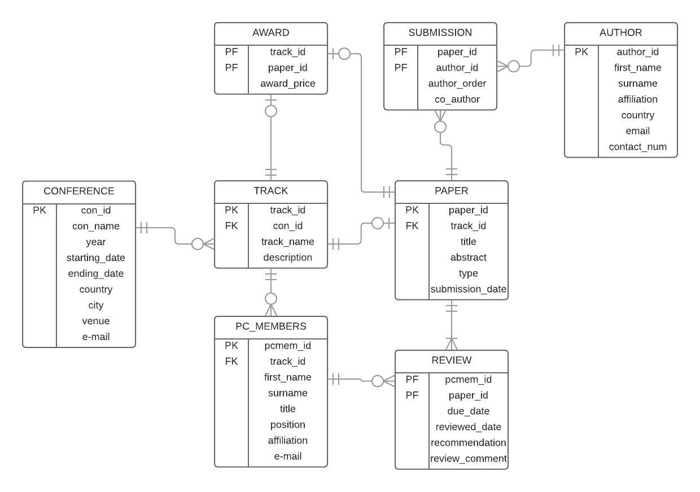

In submission table, co_author is a Boolean value, 1 means the author in this submission record is the corresponding author, 0 means not.

**4. Create index and sequence**

**Create index on Paper by attribute paper_title**

CREATE INDEX paper_index ON paper(paper_title);

**Create Sequence on each table**

CREATE SEQUENCE paper_id

START WITH 1

INCREMENT BY 1;

CREATE SEQUENCE author_id

START WITH 1

INCREMENT BY 1;

CREATE SEQUENCE mem_id

START WITH 1

INCREMENT BY 1;

CREATE SEQUENCE track_id

START WITH 1

INCREMENT BY 1;

CREATE SEQUENCE con_id

START WITH 1

INCREMENT BY 1;

**5.Population of meaningful data**

**Insert data into Conference table**

insert into CONFERENCE values (con_id.nextval,'Internet development',2010,'03-JUL-2010','03-AUG-2010','USA','New York','South Cross','internetcumm@gmail.com');

insert into CONFERENCE values (con_id.nextval,'Modern Art',2014,'01-MAY-2014','03-MAY-2014',’USA’,'Chicago','8TH ARR',chicagoart@gmail.com');

insert into CONFERENCE values (con_id.nextval,'OCEANS ',2016,'03-APR-2016','13-APR-2016','CHINA','Shanghai','Binjiang Avenue','oceans@yahoo.com'); insert into CONFERENCE values (con_id.nextval,'Global Warming',2014,'05-Jan-2014','15-Jan-2014','CHINA','Beijing','DONG SI','globalwarm@163.com');

insert into CONFERENCE values (con_id.nextval,'Wireless Tech',2016,'22-JUN-2016','29-JUN-2016','USA','Kansas','Main Ave','wireless16@gmail.com');

**Inser data into Author table**

insert into AUTHOR values(author_id.nextval,'Frank','Gab','Yale','UK','frankg@yale.edu','470700693');

insert into AUTHOR values(author_id.nextval,'Nicol','Smith','UCL','USA','nsmith@gmail.com','488359333');

insert into AUTHOR values(author_id.nextval,'Alice','Lee','IBM','USA','alicelee@ibm.org','488380633');

insert into AUTHOR values(author_id.nextval,'Chong','Lin','Peking Uni','CHINA','linchong@pku.edu.cn','1353844959');

insert into AUTHOR values(author_id.nextval,'Kusimi','Haku','Tokyo Uni','JAPAN','hakuk@yahoo.jp','83798734');

insert into AUTHOR values(author_id.nextval,'Lucy','White','Monash Uni','AUS','lwhite@monash.edu','466849885');

insert into AUTHOR values(author_id.nextval,'Leo','Torres','KCL','SPAIN','leotorres@kcl.edu','788707893');

insert into AUTHOR values(author_id.nextval,'Nancy','Lopez','Yale','UK','nlopez@yale.edu','470778678');

insert into AUTHOR values(author_id.nextval,'XiaoRan','Deng','Peking Uni','CHINA','dengxr@pku.edu.cn','1503422234');

insert into AUTHOR values(author_id.nextval,'Jack','Irwan','Yale','UK','jirwan@yale.edu','470767868');

insert into AUTHOR values(author_id.nextval,'Mike','Jason','UCL','USA','mjason@gmail.com','484569363');

insert into AUTHOR values(author_id.nextval,'David','Cook','UCL','CANADA','ddcook@gmail.com','463459365');

insert into AUTHOR values(author_id.nextval,'Lon','Kin','Peking Uni','CHINA','kinlon@pku.edu.cn','1503434564');

**Insert data into Track table**

insert into TRACK values(track_id.nextval,6,'Ocean Resource and Development');

insert into TRACK values(track_id.nextval,3,'Big Data Research');

insert into TRACK values(track_id.nextval,3,'Mobile and Distribute');

insert into TRACK values(track_id.nextval,8,'New Tech Share');

insert into TRACK values(track_id.nextval,10,'Security');

**Insert data into Paper table**

insert into paper values(paper_id.nextval,'The Future of Ocean Resource Development','With the new technology for oceans exploitation...','Research-in-Progress papers','03-JAN-2016','1');

insert into paper values(paper_id.nextval,'Significance and Challenges of Big Data Research','In recent years, the rapid development of Internet, Internet of Things, and Cloud Computing have led to the explosive growth of data in almost every industry and business area...','full paper','03-MAY-2010','2');

insert into paper values(paper_id.nextval,'The Indian Ocean nodule field geology and resource potential','The paper includes a synthesis of research findings on the structure and evolution of the Central Indian Ocean Basin and its ferromanganese deposits...','full paper','20-JAN-2016','1');

insert into paper values(paper_id.nextval,'Decomposing social in emerging big data research','This study conducts a social network analysis of international co-authorship relationships in “big data” science and analyzes semantic networks','full paper','23-JUN-2010','2');

insert into paper values(paper_id.nextval,'Complex event process infrastructure in mobile distributed system','With the growing success of the mobile computing devices, such as laptop computer, third generation mobile phone, personal digital assistant...','full paper','22-FEB-2010','3');

insert into paper values(paper_id.nextval,'Three-Phase Algorithms for Task Scheduling in Distributed Mobile System','A distributed mobile DSP system consists of a group of mobile devices with different computing powers.','Research-in-Progress papers','04-JAN-2010','3');

insert into paper values(paper_id.nextval,'CO2 capture, transport and industrial applications','Carbon dioxide (CO2) capture and storage (CCS) is the one advanced technology that conventional power generation cannot do without. CCS technology reduces the carbon...','full paper','20-DEC-2013','4');

insert into paper values(paper_id.nextval,'Carbon dioxide recovery and utilization','Carbon Dioxide Recovery and Utilization is a complete and informative resource on the carbon dioxide sources and market at the European Union level...','full paper','11-DEC-2013','4');

insert into paper values(paper_id.nextval,'Wireless Network Security: Building on Erasures','Proceedings of the IEEE.Description: One of the most widely-known techniques for securing a message...','full paper','03-APR-2016','5');

insert into paper values(paper_id.nextval,'Signal-flow-based analysis of security protocols','Security protocols operating over wireless channels can incur significant communication costs (e.g., energy, delay), ...','full paper','05-APR-2016','5');

**Insert data into Submission table**

insert into submission values(2,4,1,1);

insert into submission values(2,9,2,0);

insert into submission values(3,1,1,1);

insert into submission values(3,3,2,0);

insert into submission values(5,2,1,1);

insert into submission values(8,11,1,1);

insert into submission values(8,12,2,0);

insert into submission values(10,6,1,1);

insert into submission values(9,5,1,1);

insert into submission values(13,5,1,1);

insert into submission values(15,11,1,1);

insert into submission values(15,2,2,0);

insert into submission values(13,13,1,1);

insert into submission values(20,10,1,1);

**Insert data into award table**

insert into award values('10000','1','2');

insert into award values('5000','2','3');

insert into award values('24000','3','15');

insert into award values('5000','4','8');

insert into award values('7000','5','10');

**Insert data into Pc Member table**

insert into pc_member values(mem_id.nextval,'Robert','Murray','Dr','researcher','MIT','mrobert@gmail.com',3);

insert into pc_member values(mem_id.nextval,'Amanda','Ryan','Prof','lecturer','MIT','amaryan@gmail.com',3);

insert into pc_member values(mem_id.nextval,'Joe','Ramer','Prof','lecturer','Havard','jramer32@gmail.com',3);

insert into pc_member values(mem_id.nextval,'Yasaku','Sanso','Dr','researcher','Tokyo Uni','sanso333@yahoo.jp',1);

insert into pc_member values(mem_id.nextval,'Billy','Logan','Prof','lecturer','Cambridge','blogan@cambridge.edu',2);

**Insert data into Review table**

insert into review values(1,15,'24-FEB-2010','accept','15-MAR-2010','Really good view about a new type of...');

insert into review values(2,15,'25-FEB-2010','accept','15-MAR-2010','A new idea about...');

insert into review values(3,15,'24-FEB-2010','accept','15-MAR-2010','Great work...');

insert into review values(4,13,'25-JAN-2016','weak reject','27-FEB-2016','Unprovable idea...');

insert into review values(5,5,'27-JUN-2010','accept','12-JUL-2010','GOOD,no doubt to be the...');

**Task 2**

**create Oracle Stored Procedure**

DELIMITER //

create or replace procedure updateVenue(

p_con_id in conference.con_id%type,

p_venue in conference.venue%type)

is

begin

update conference

set

venue = p_venue

where con_id = p_con_id;

END;

/

**Before updating venue:**

SELECT * FROM S26610000.CONFERENCE;

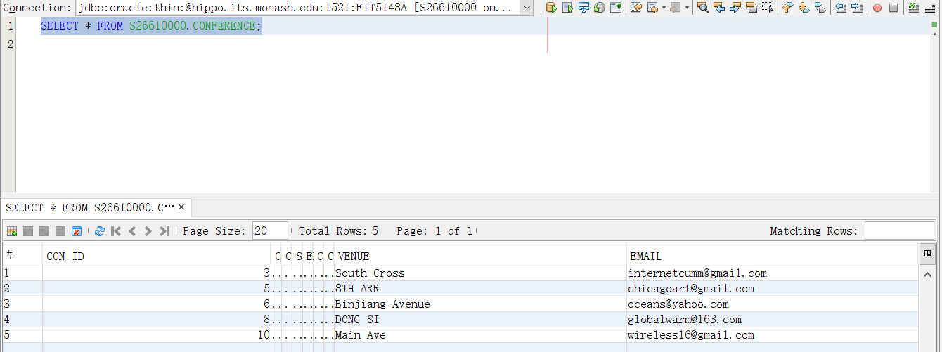

**Use updateVenue procedure**

call updateVenue(3,'South Cross XXXXX');

SELECT * FROM S26610000.CONFERENCE;

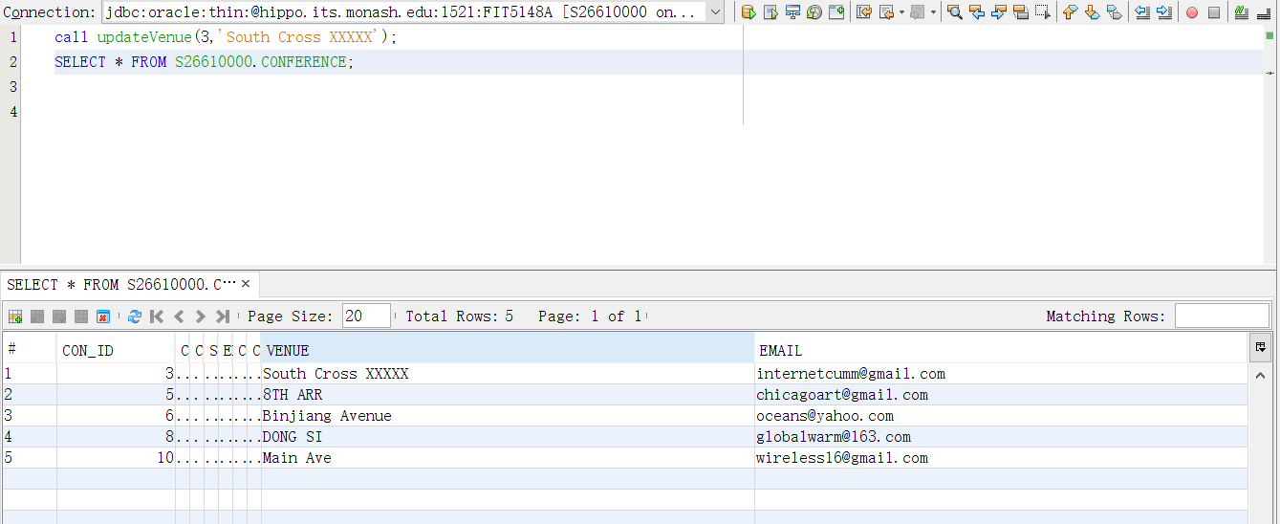

**Task 3.**

**When update track or insert a new record of track, it is necessary to make sure the conference id is already existed.**

DELIMITER //

CREATE OR REPLACE TRIGGER change_track

Before

UPDATE OR INSERT ON TRACK

FOR EACH ROW

DECLARE countvalue number;

BEGIN

IF INSERTING OR UPDATING THEN

SELECT COUNT(*) INTO countvalue FROM CONFERENCE@FIT5148A C

WHERE C.CON_ID = :new.CONFERENCE_CON_ID;

IF countvalue = 0

THEN RAISE_APPLICATION_ERROR(-20002, 'THE VALUE OF FOREIGN KEY SHOULD EQUAL TO THE VALUE OF PRIMARY KEY');

END IF;

END IF;

END;

/

**When delete a conference record, users need to make sure there is no record in track table is related to this conference.**

DELIMITER //

CREATE OR REPLACE TRIGGER change_conference

Before

DELETE ON CONFERENCE

FOR EACH ROW

DECLARE countvalue number;

BEGIN

IF DELETING THEN

SELECT COUNT(*) INTO countvalue FROM TRACK@FIT5148B C

WHERE C.CONFERENCE_CON_ID = :old.CON_ID;

IF countvalue > 0

THEN RAISE_APPLICATION_ERROR(-20002, 'THE VALUE OF FOREIGN KEY SHOULD EQUAL TO THE VALUE OF PRIMARY KEY');

END IF;

END IF;

END;

/

**Task 4**

**a) Horizontal fragmentation**

**Assumption**:

All of the conferences in the database are held in two countries, China or USA. So it is necessary to separate CONFERENCE table into two fragments to make it easier for users to search the conferences they want to know about.

List of applications:

Application1: Find the information about each conference which is held in USA

Application2: Find the information about each conference which is held in China

For application1 :

P1 : (LOC=”USA”)

~~P2：not(LOC=”USA”)~~ equals LOC=”CHINA”

For application2:

P2: (LOC=”CHINA”)

~~P3: not(LOC=”CHINA”)~~ equals LOC=”USA”

elimination:

~~P3: (LOC=”USA”) ∧ (LOC=”CHINA”)~~

~~P4: not(LOC=”USA”) ∧ not(LOC=”CHINA”)~~

Minterm fragments left after elimination

m1: (LOC=”USA”)

m2: (LOC=”CHINA”)

**At FIT5148A**

create table conference_fragment_a as

(select * from conference@FIT5148A

where country = 'USA');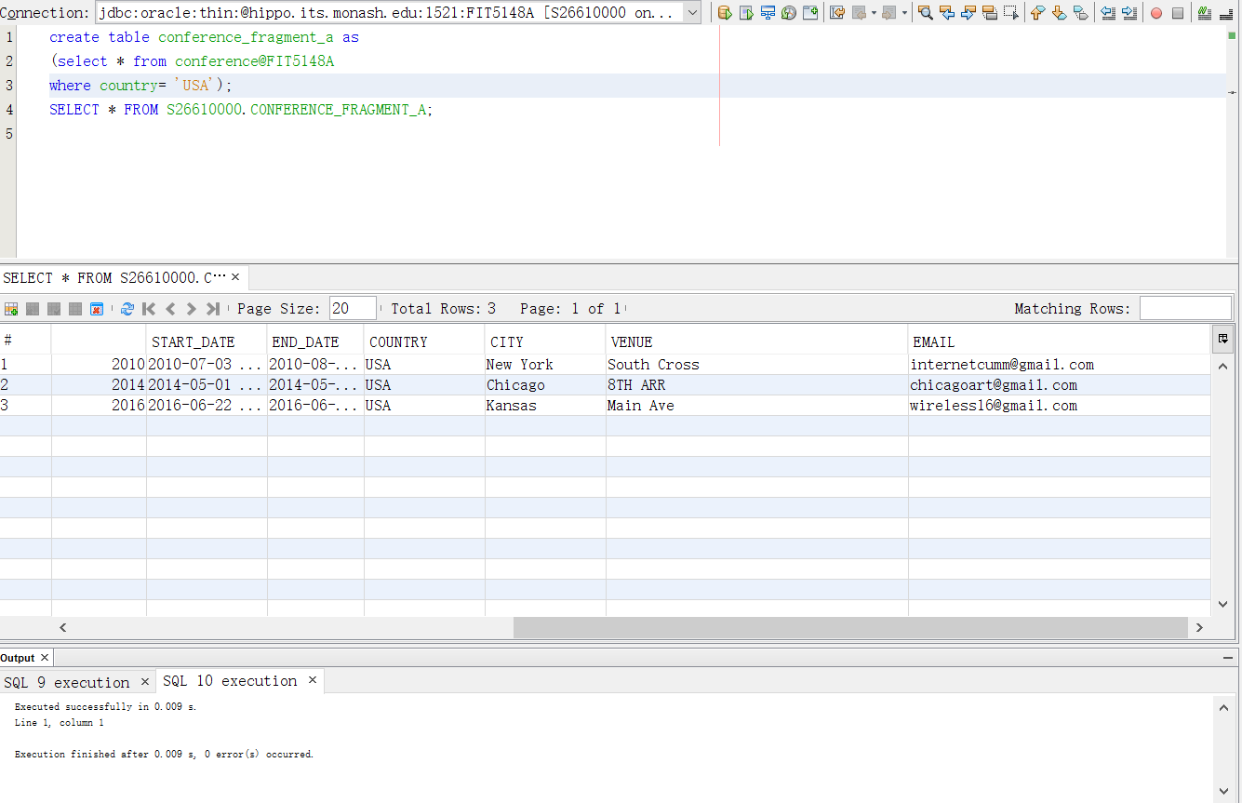

**At FIT5148B**

create table conference_fragment_b as

(select * from conference@FIT5148A

where country= 'CHINA');

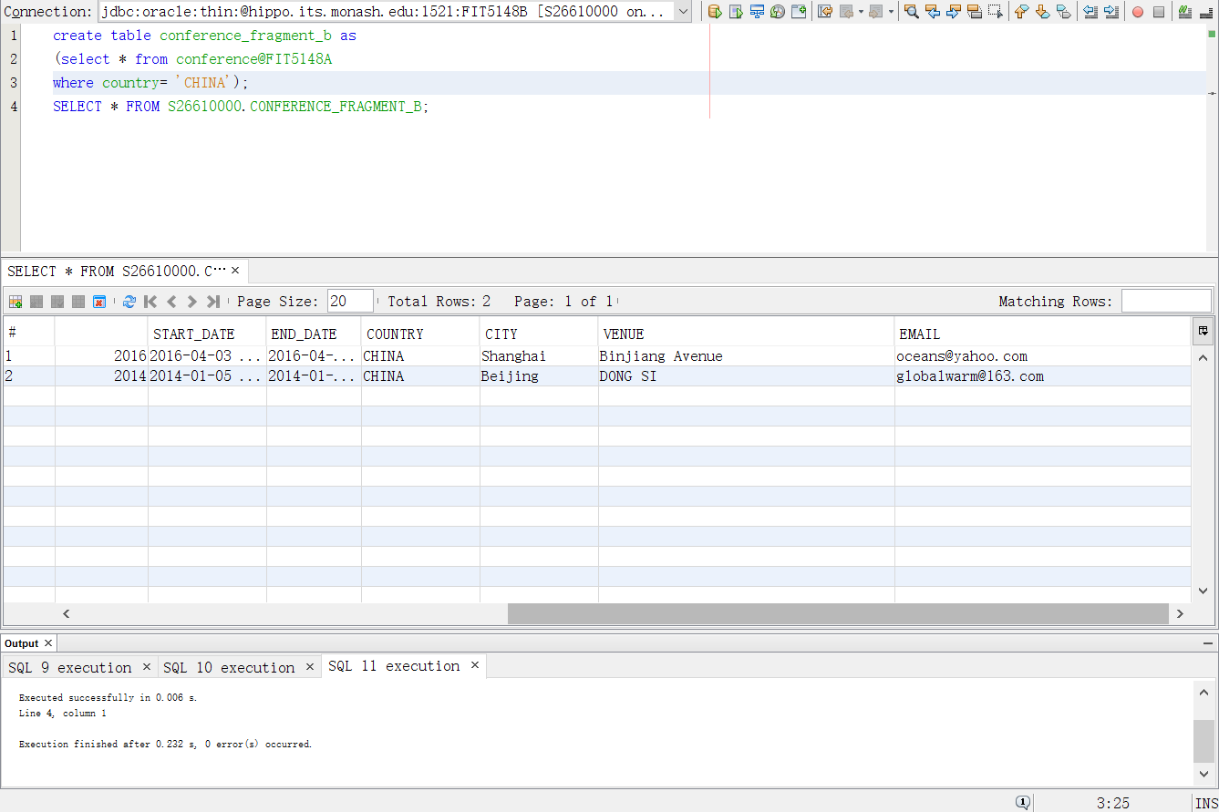

**b) Vertical fragmentation**

In this conference system, PAPER table is the most vital table because users will search in this table a lot to find the information about the paper they are interested in. Different users may focus on different kind of information about the paper, So that’s why I choose paper table to do the vertical fragmentation.

**Four queries:**

q1: select paper_title from paper where paper_id = value;

q2: select track_id from paper where paper_title = value;

q3: select paper_abstract, paper_type from paper where paper_title = value;

q4: select submit_date from paper where track_id = value;

**Usage Matrix**

Because paper_id is the primary key so it has to be in every fragment, that’s why it is unnecessary to put it into usage matrix

A1: paper_title

A2: paper_abstract

A3: paper_type

A4: submit_time

A5: track_id

A1 A2 A3 A4 A5

q1 1 0 0 0 0

q2 1 0 0 0 1

q3 1 1 1 0 0

q4 0 0 0 1 1

**Access Frequency Matrix**

S1 S2 sum

q1 5 20 25

q2 30 15 45

q3 15 20 35

q4 0 5 5

**Attribute Affinity Matrix**

A1 A2 A3 A4 A5

A1 105 35 35 0 45

A2 35 35 35 0 0

A3 35 35 35 0 0

A4 0 0 0 5 5

A5 45 0 0 5 50

According to the result of affinity matrix, paper_title and track_id plus PK paper_id should be in one site. Paper_ abstract, paper_type and submit_time plus PK are in the other site

**At FIT5148A**

create table paper_fragment_a as

(select paper_id,paper_title,track_track_id from paper@FIT5148B);

SELECT * FROM S26610000.PAPER_FRAGMENT_A;

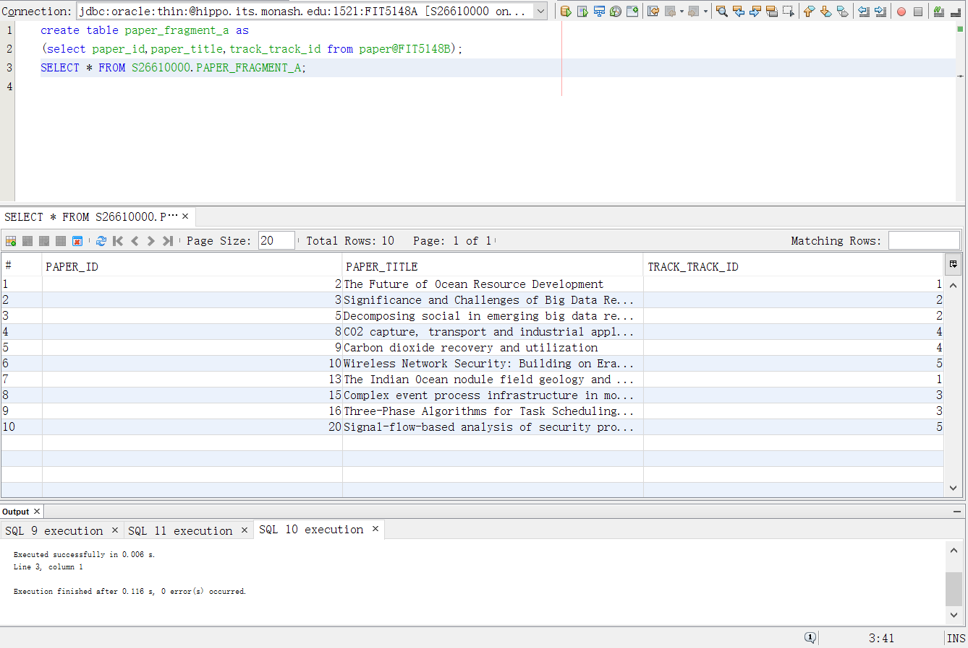

**At FIT5148B**

create table paper_fragment_b as

(select paper_id,paper_abstract,paper_type,submit_date from paper@FIT5148B);

SELECT * FROM S26610000.PAPER_FRAGMENT_B;

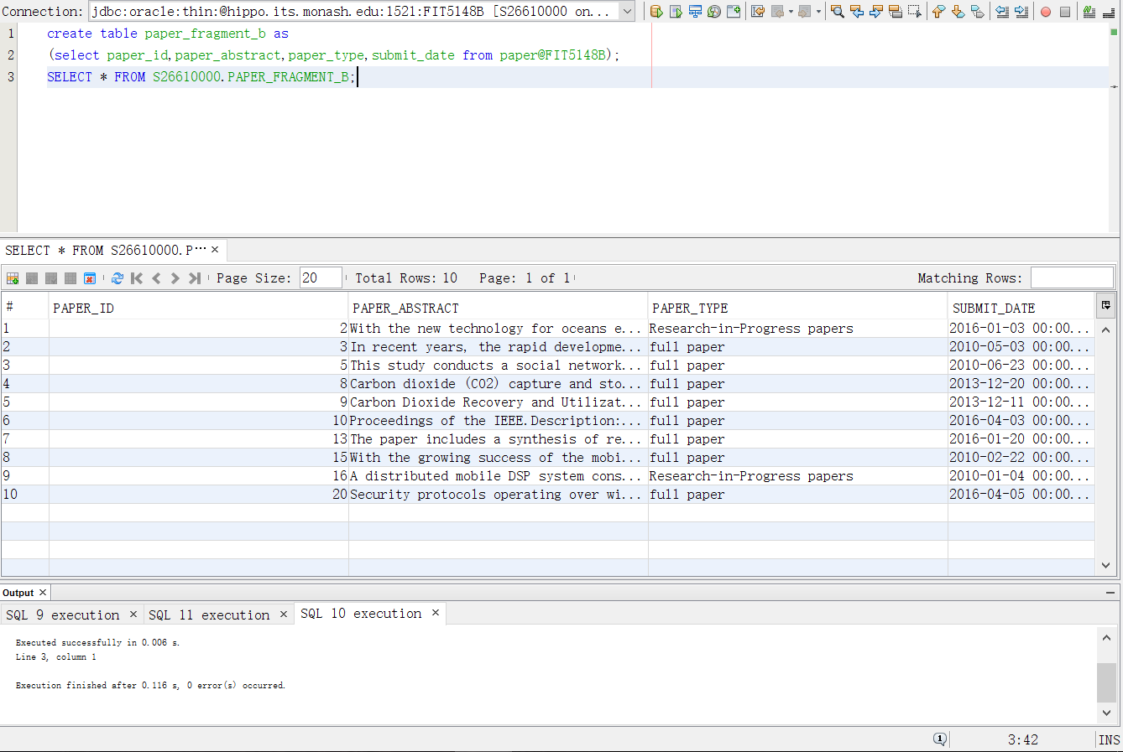

**Task 5.**

**Main Frame**

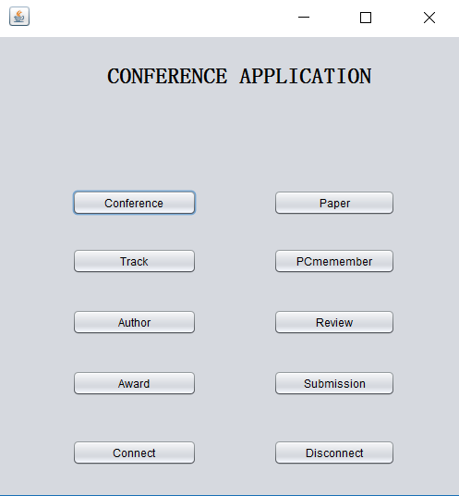

private void jButton1ActionPerformed(java.awt.event.ActionEvent evt) {

ConferenceFrame ConferenceFrame = new ConferenceFrame();

ConferenceFrame.setVisible(true);

ConferenceFrame.setDefaultCloseOperation(ConferenceFrame.DISPOSE_ON_CLOSE);

}

private void jButton2ActionPerformed(java.awt.event.ActionEvent evt) {

TrackFrame TrackFrame = new TrackFrame();

TrackFrame.setVisible(true);

TrackFrame.setDefaultCloseOperation(TrackFrame.DISPOSE_ON_CLOSE);

}

private void jButton3ActionPerformed(java.awt.event.ActionEvent evt) {

AuthorFrame AuthorFrame = new AuthorFrame();

AuthorFrame.setVisible(true);

AuthorFrame.setDefaultCloseOperation(AuthorFrame.DISPOSE_ON_CLOSE);

}

private void jButton4ActionPerformed(java.awt.event.ActionEvent evt) {

AwardFrame AwardFrame = new AwardFrame();

AwardFrame.setVisible(true);

AwardFrame.setDefaultCloseOperation(AwardFrame.DISPOSE_ON_CLOSE);

}

private void jButton5ActionPerformed(java.awt.event.ActionEvent evt) {

PaperFrame PaperFrame = new PaperFrame();

PaperFrame.setVisible(true);

PaperFrame.setDefaultCloseOperation(PaperFrame.DISPOSE_ON_CLOSE);

}

private void jButton6ActionPerformed(java.awt.event.ActionEvent evt) {

PcmemeberFrame PcmemeberFrame = new PcmemeberFrame();

PcmemeberFrame.setVisible(true);

PcmemeberFrame.setDefaultCloseOperation(PcmemeberFrame.DISPOSE_ON_CLOSE);

}

private void jButton7ActionPerformed(java.awt.event.ActionEvent evt) {

ReviewFrame ReviewFrame = new ReviewFrame();

ReviewFrame.setVisible(true);

ReviewFrame.setDefaultCloseOperation(ReviewFrame.DISPOSE_ON_CLOSE);

}

private void jButton8ActionPerformed(java.awt.event.ActionEvent evt) {

SubmissionFrame SubmissionFrame = new SubmissionFrame();

SubmissionFrame.setVisible(true);

SubmissionFrame.setDefaultCloseOperation(SubmissionFrame.DISPOSE_ON_CLOSE);

}

private void closeActionPerformed(java.awt.event.ActionEvent evt) {

try{

conn1.close();

System.out.println("Connection A closed");

conn2.close();

System.out.println("Connection B closed");

} catch(SQLException ex){

System.out.println("error in closing connection");

} // TODO add your handling code here:

}

private void startActionPerformed(java.awt.event.ActionEvent evt) {

try {

DriverManager.registerDriver (new OracleDriver());

conn1 = DriverManager.getConnection ("jdbc:oracle:thin:@hippo.its.monash.edu.au:1521:FIT5148a", "S26610000", "student");

System.out.println("Connected to Database A");

conn2 = DriverManager.getConnection ("jdbc:oracle:thin:@hippo.its.monash.edu.au:1521:FIT5148b", "S26610000", "student");

System.out.println("Connected to Database B");

}

catch(SQLException f)

{

System.out.println("error in connection");

}

}

{

}

**Conference Frame**

**View**

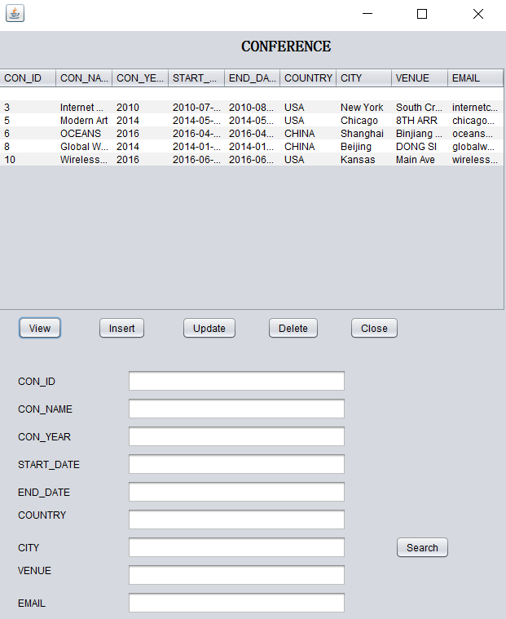

private void jButton1ActionPerformed(java.awt.event.ActionEvent evt) {

try {

dtm.setRowCount(0);

stmt = ConferenceApp.conn1.createStatement();

rset = stmt.executeQuery("select * from conference");

ResultSetMetaData mdata = rset.getMetaData();

int numberOfColumns = mdata.getColumnCount();

while (rset.next()) {

Object[] rowData = new Object[numberOfColumns];

for (int i = 0; i < rowData.length; i++) {

rowData[i] = rset.getObject(i + 1);

}

dtm.addRow(rowData);

}

} catch (SQLException f) {

System.out.println(f.getMessage());

}

}

**Insert**

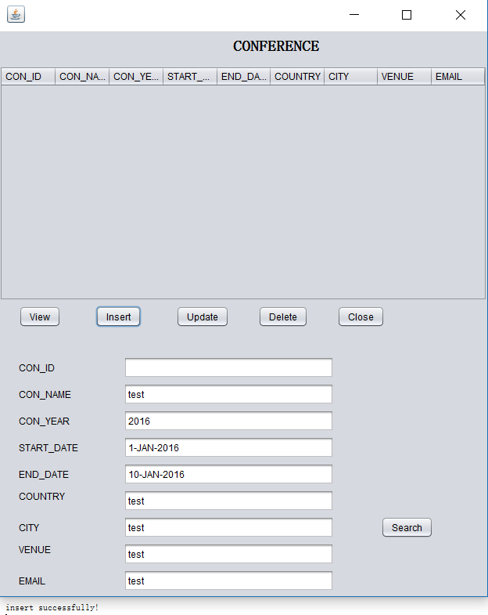

private void jButton3ActionPerformed(java.awt.event.ActionEvent evt) {

String conname = jTextField2.getText();

String conyear = jTextField3.getText();

String startdate= jTextField4.getText();

String enddate = jTextField5.getText();

String country = jTextField6.getText();

String city = jTextField7.getText();

String venue = jTextField8.getText();

String email = jTextField9.getText();

dtm.setRowCount(0);

try {

stmt = ConferenceApp.conn1.createStatement();

rset = stmt.executeQuery(

"insert into conference values(con_id.nextval,'"+conname+"','"+conyear+"','"+startdate+"','"+enddate+"','"+country+"','"+city+"','"+venue+"','"+email+"')");

System.out.println("insert successfully!");

} catch (SQLException f) {

System.out.println(f.getMessage());

} }

**update**

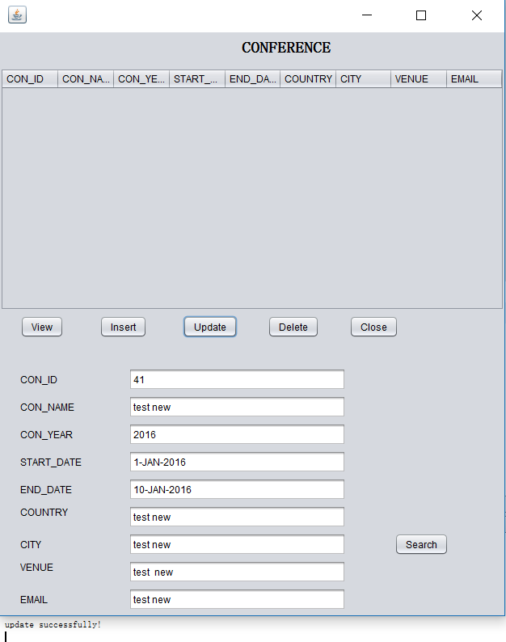

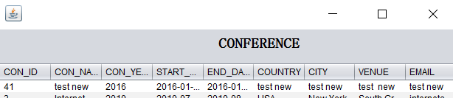

rivate void jButton4ActionPerformed(java.awt.event.ActionEvent evt) {

int conid = Integer.parseInt(jTextField1.getText());

String conname = jTextField2.getText();

String conyear = jTextField3.getText();

String startdate= jTextField4.getText();

String enddate = jTextField5.getText();

String country = jTextField6.getText();

String city = jTextField7.getText();

String venue = jTextField8.getText();

String email = jTextField9.getText();

dtm.setRowCount(0);

try {

stmt = ConferenceApp.conn1.createStatement();

rset = stmt.executeQuery(

"update conference set con_name='"+conname+"',con_year='"+conyear+"',start_date='"+startdate+"',end_date='"+enddate+"',"

+ "country='"+country+"',city='"+city+"',venue='"+venue+"',email='"+email+"'where con_id="+conid);

System.out.println("update successfully!");

} catch (SQLException f) {

System.out.println(f.getMessage());

} // TODO add your handling code here:

}

**Delete**

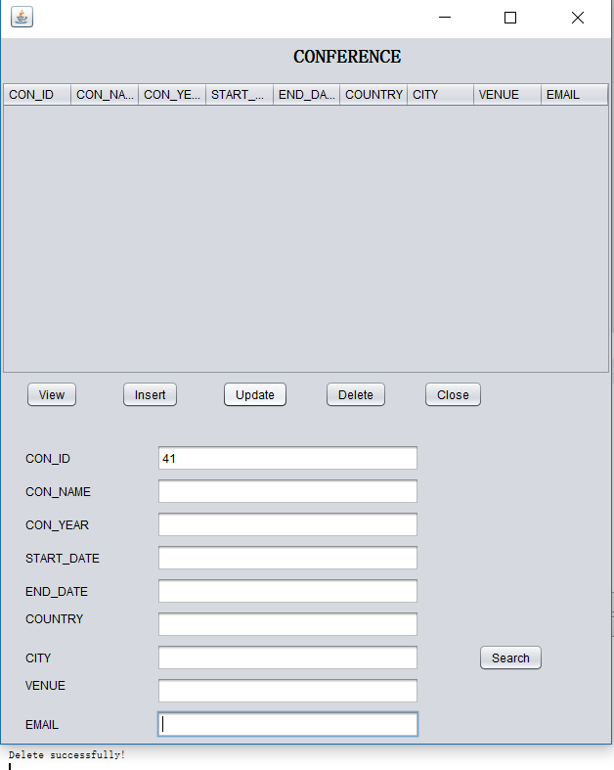

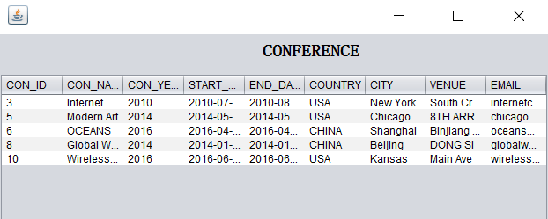

private void jButton5ActionPerformed(java.awt.event.ActionEvent evt) {

int conid = Integer.parseInt(jTextField1.getText());

dtm.setRowCount(0);

try {

stmt = ConferenceApp.conn1.createStatement();

rset = stmt.executeQuery(

"delete from conference where con_id ="+ conid);

System.out.println("Delete successfully!");

}

catch (SQLException f) {

System.out.println(f.getMessage());

}

}

**Search by city**

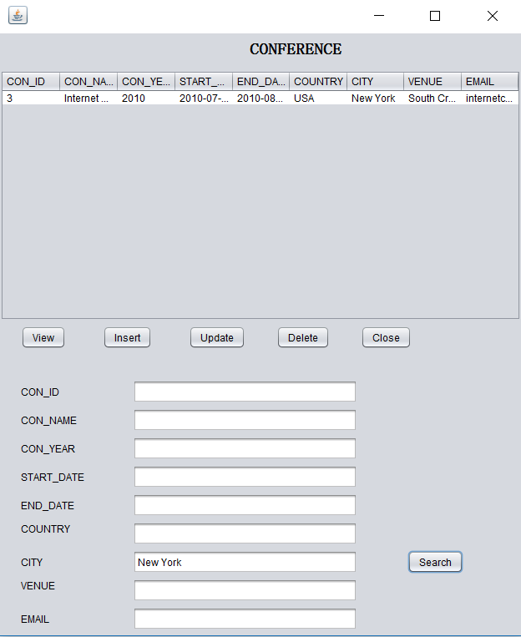

private void jButton6ActionPerformed(java.awt.event.ActionEvent evt) {

String search = jTextField7.getText();

try {

stmt = ConferenceApp.conn1.createStatement();

rset = stmt.executeQuery

("select * from conference where city = '" + search+"'");

System.out.println("search successful");

ResultSetMetaData mdata = rset.getMetaData();

dtm.setRowCount(0);

int numberOfColumns = mdata.getColumnCount();

while (rset.next()) {

Object[] rowData = new Object[numberOfColumns];

for (int i = 0; i < rowData.length; i++) {

rowData[i] = rset.getObject(i + 1);

}

dtm.addRow(rowData);

}

} catch (SQLException f) {

System.out.println(f.getMessage());

} // TODO add your handling code here:

}

**Track Frame**

**View**

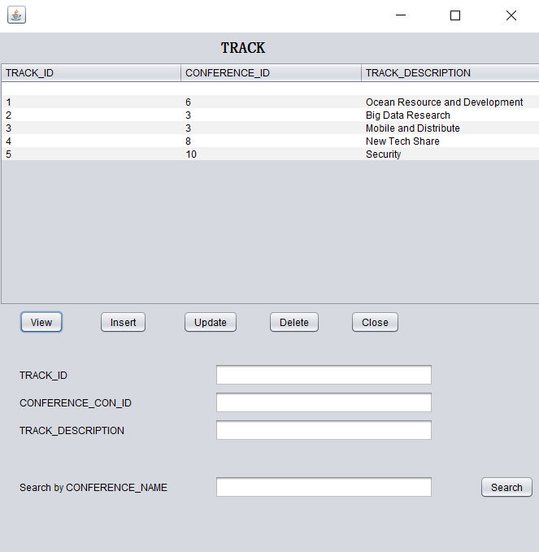

private void jButton1ActionPerformed(java.awt.event.ActionEvent evt) {

try {

dtm.setRowCount(0);

stmt = ConferenceApp.conn2.createStatement();

rset = stmt.executeQuery("select * from track");

ResultSetMetaData mdata = rset.getMetaData();

int numberOfColumns = mdata.getColumnCount();

while (rset.next()) {

Object[] rowData = new Object[numberOfColumns];

for (int i = 0; i < rowData.length; i++) {

rowData[i] = rset.getObject(i + 1);

}

dtm.addRow(rowData);

}

} catch (SQLException f) {

System.out.println(f.getMessage());

} // TODO add your handling code here:

}

**Insert**

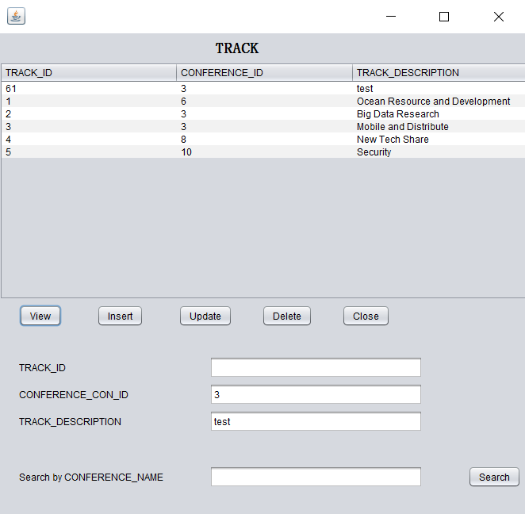

private void jButton3ActionPerformed(java.awt.event.ActionEvent evt) {

String conference_con_id = jTextField2.getText();

String track_description = jTextField3.getText();

dtm.setRowCount(0);

try {

stmt = ConferenceApp.conn2.createStatement();

rset = stmt.executeQuery(

"insert into track values(track_id.nextval,'"+conference_con_id+"','"+track_description+"')");

System.out.println("insert successfully!");

} catch (SQLException f) {

System.out.println(f.getMessage());

} // TODO add your handling code here:

}

**Update**

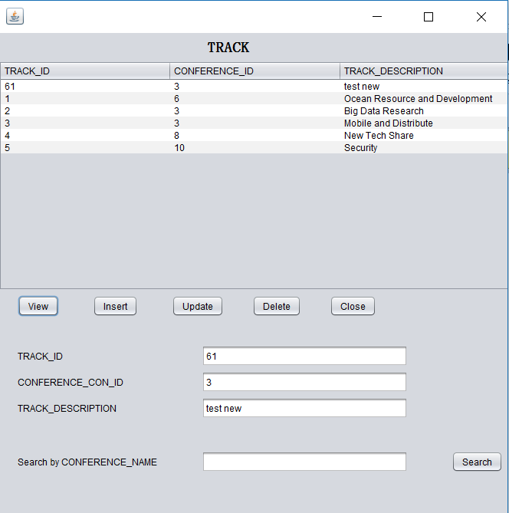

private void jButton4ActionPerformed(java.awt.event.ActionEvent evt) {

int trackid = Integer.parseInt(jTextField1.getText());

String conference_con_id = jTextField2.getText();

String track_description = jTextField3.getText();

dtm.setRowCount(0);

try {

stmt = ConferenceApp.conn2.createStatement();

rset = stmt.executeQuery(

"update track set conference_con_id='"+conference_con_id+"',track_description='"+track_description+"' where track_id="+trackid);

System.out.println("update successfully!");

} catch (SQLException f) {

System.out.println(f.getMessage());

} // TODO add your handling code here:

}

**Delete**

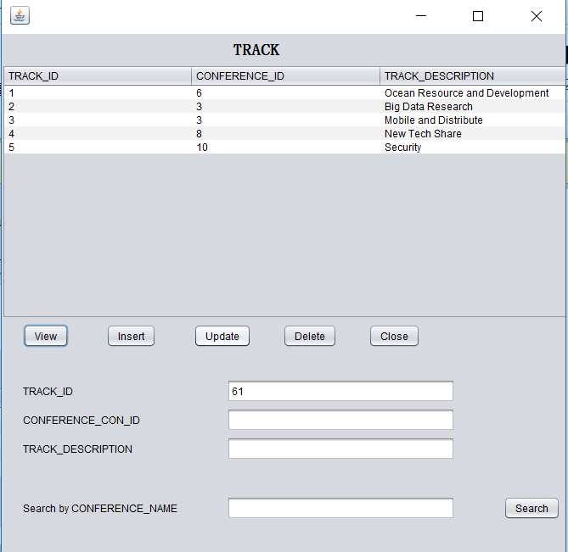

private void jButton5ActionPerformed(java.awt.event.ActionEvent evt) {

int trackid = Integer.parseInt(jTextField1.getText());

dtm.setRowCount(0);

try {

stmt = ConferenceApp.conn2.createStatement();

rset = stmt.executeQuery(

"delete from track where track_id ="+ trackid);

System.out.println("Delete successfully!");

}

catch (SQLException f) {

System.out.println(f.getMessage());

} // TODO add your handling code here:

}

**Search by conference’s name**

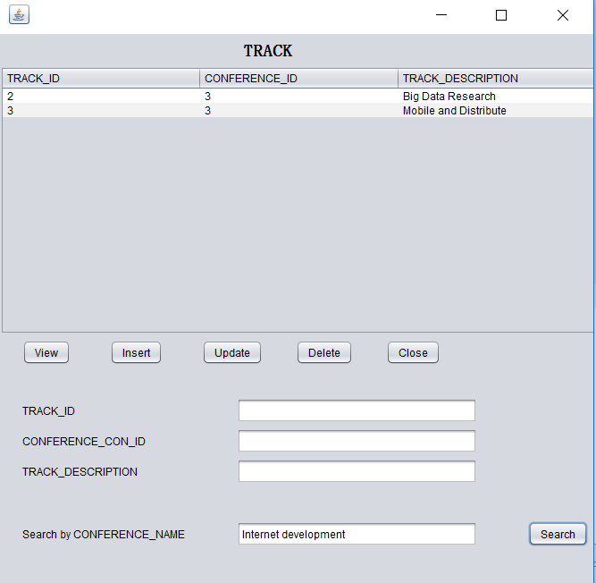

private void jButton6ActionPerformed(java.awt.event.ActionEvent evt) {

String search = jTextField7.getText();

try {

stmt = ConferenceApp.conn2.createStatement();

rset = stmt.executeQuery

("select * from track t join conference@FIT5148A c on t.conference_con_id=c.con_id where c.con_name = '" + search+"'");

System.out.println("search successful");

ResultSetMetaData mdata = rset.getMetaData();

dtm.setRowCount(0);

int numberOfColumns = mdata.getColumnCount();

while (rset.next()) {

Object[] rowData = new Object[numberOfColumns];

for (int i = 0; i < rowData.length; i++) {

rowData[i] = rset.getObject(i + 1);

}

dtm.addRow(rowData);

}

**Author Frame**

**View**

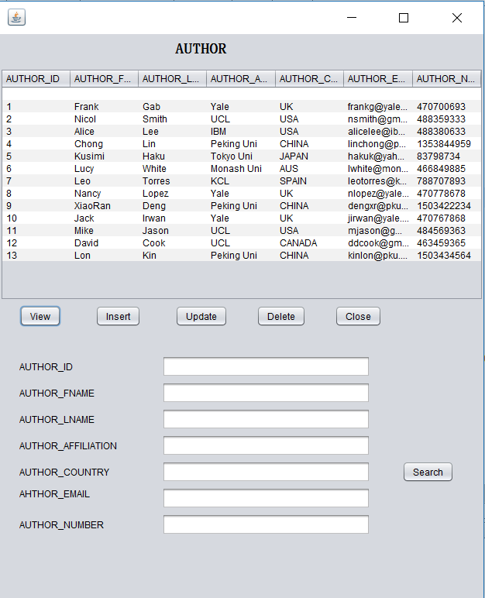

private void jButton1ActionPerformed(java.awt.event.ActionEvent evt) {

try {

dtm.setRowCount(0);

stmt = ConferenceApp.conn2.createStatement();

rset = stmt.executeQuery("select * from author");

ResultSetMetaData mdata = rset.getMetaData();

int numberOfColumns = mdata.getColumnCount();

while (rset.next()) {

Object[] rowData = new Object[numberOfColumns];

for (int i = 0; i < rowData.length; i++) {

rowData[i] = rset.getObject(i + 1);

}

dtm.addRow(rowData);

}

} catch (SQLException f) {

System.out.println(f.getMessage());

} // TODO add your handling code here:

}

**Insert**

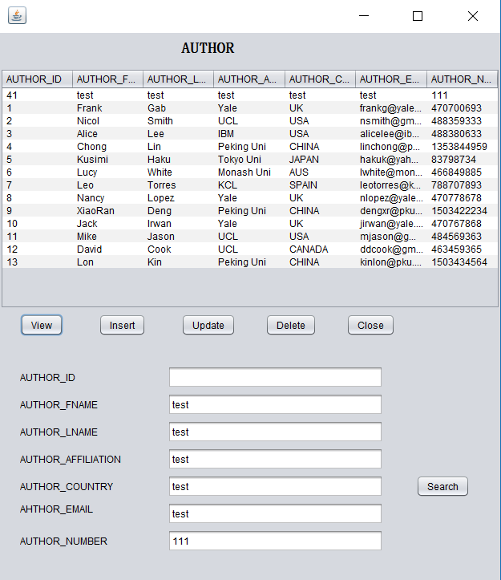

private void jButton3ActionPerformed(java.awt.event.ActionEvent evt) {

String fname = jTextField2.getText();

String lname = jTextField3.getText();

String affiliation= jTextField4.getText();

String country = jTextField5.getText();

String email = jTextField6.getText();

String number = jTextField7.getText();

dtm.setRowCount(0);

try {

stmt = ConferenceApp.conn2.createStatement();

rset = stmt.executeQuery(

"insert into author values(author_id.nextval,'"+fname+"','"+lname+"','"+affiliation+"','"+country+"','"+email+"','"+number+"')");

System.out.println("insert successfully!");

} catch (SQLException f) {

System.out.println(f.getMessage());

} // TODO add your handling code here:

}

**Update**

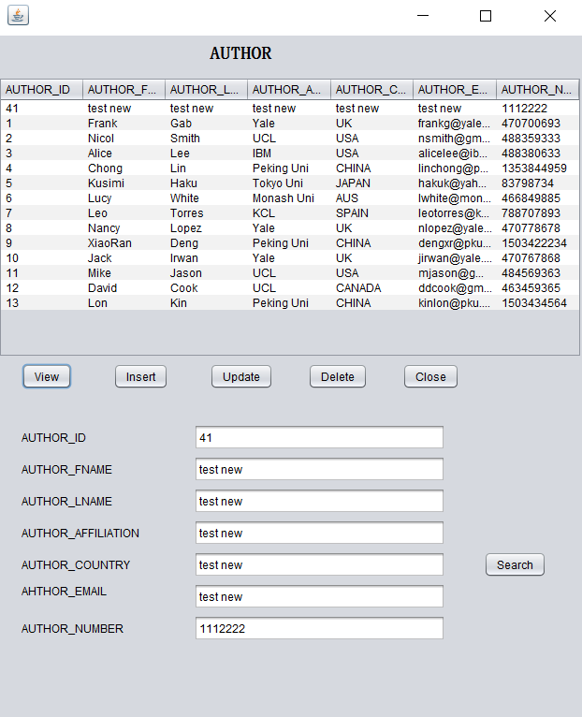

private void jButton4ActionPerformed(java.awt.event.ActionEvent evt) {

int authorid = Integer.parseInt(jTextField1.getText());

String fname = jTextField2.getText();

String lname = jTextField3.getText();

String affiliation= jTextField4.getText();

String country = jTextField5.getText();

String email = jTextField6.getText();

String number = jTextField7.getText();

dtm.setRowCount(0);

try {

stmt = ConferenceApp.conn2.createStatement();

rset = stmt.executeQuery(

"update author set author_fname='"+fname+"',author_lname='"+lname+"',author_affiliation='"+affiliation+"',author_country='"+country+"',"

+ "author_email='"+email+"',author_number='"+number+"'where author_id="+authorid);

System.out.println("update successfully!");

} catch (SQLException f) {

System.out.println(f.getMessage());

} // TODO add your handling code here:

}

**Delete**

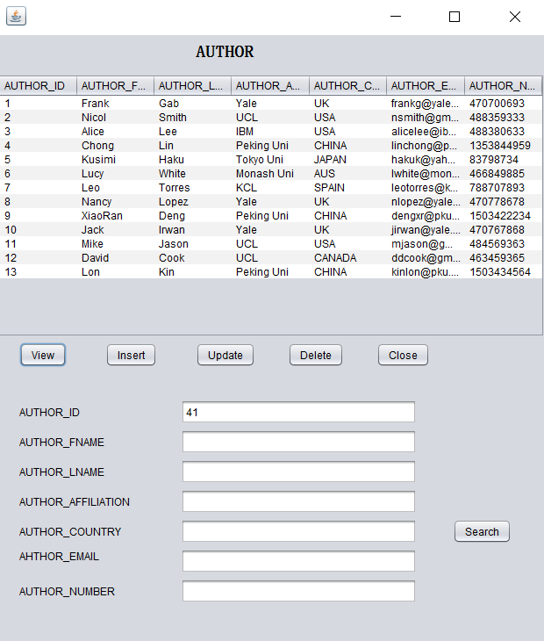

private void jButton5ActionPerformed(java.awt.event.ActionEvent evt) {

int authorid = Integer.parseInt(jTextField1.getText());

dtm.setRowCount(0);

try {

stmt = ConferenceApp.conn2.createStatement();

rset = stmt.executeQuery(

"delete from author where author_id ="+ authorid);

System.out.println("Delete successfully!");

}

catch (SQLException f) {

System.out.println(f.getMessage());

} // TODO add your handling code here:

}

**Search by country**

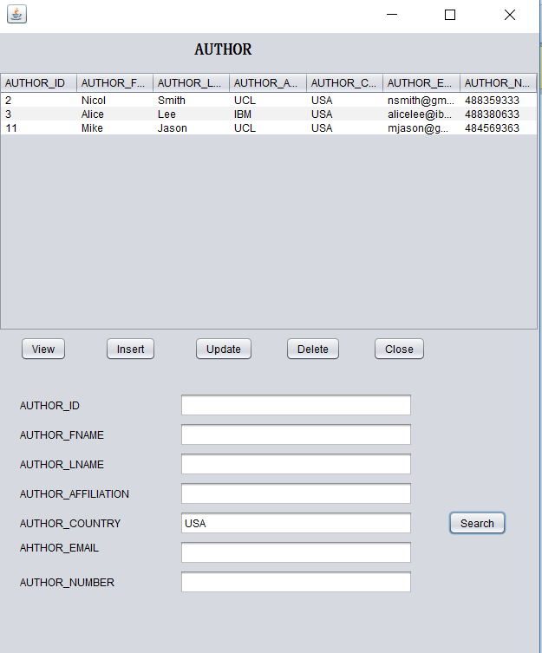

private void jButton6ActionPerformed(java.awt.event.ActionEvent evt) {

String search = jTextField5.getText();

try {

stmt = ConferenceApp.conn2.createStatement();

rset = stmt.executeQuery

("select * from author where author_country = '" + search+"'");

System.out.println("search successful");

ResultSetMetaData mdata = rset.getMetaData();

dtm.setRowCount(0);

int numberOfColumns = mdata.getColumnCount();

while (rset.next()) {

Object[] rowData = new Object[numberOfColumns];

for (int i = 0; i < rowData.length; i++) {

rowData[i] = rset.getObject(i + 1);

}

dtm.addRow(rowData);

}

} catch (SQLException f) {

System.out.println(f.getMessage());

} // TODO add your handling code here:

}

**PCmember Frame**

**View**

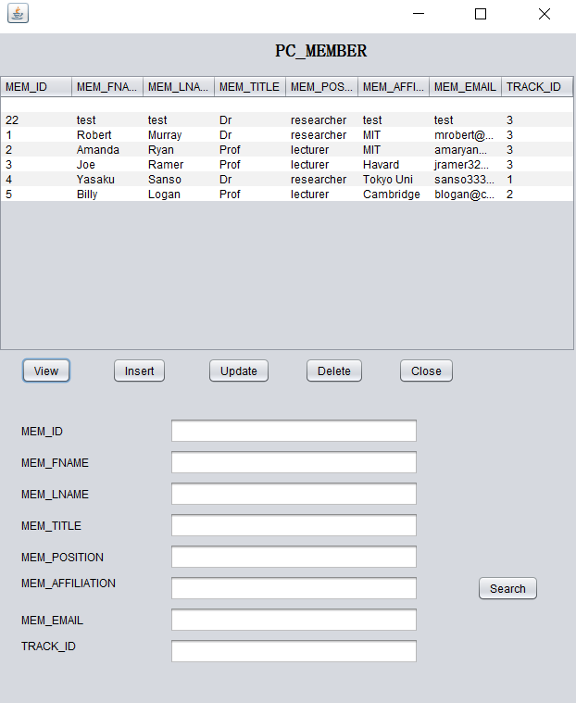

private void jButton1ActionPerformed(java.awt.event.ActionEvent evt) {

try {

dtm.setRowCount(0);

stmt = ConferenceApp.conn2.createStatement();

rset = stmt.executeQuery("select * from pc_member");

ResultSetMetaData mdata = rset.getMetaData();

int numberOfColumns = mdata.getColumnCount();

while (rset.next()) {

Object[] rowData = new Object[numberOfColumns];

for (int i = 0; i < rowData.length; i++) {

rowData[i] = rset.getObject(i + 1);

}

dtm.addRow(rowData);

}

} catch (SQLException f) {

System.out.println(f.getMessage());

} // TODO add your handling code here:

}

**Insert**

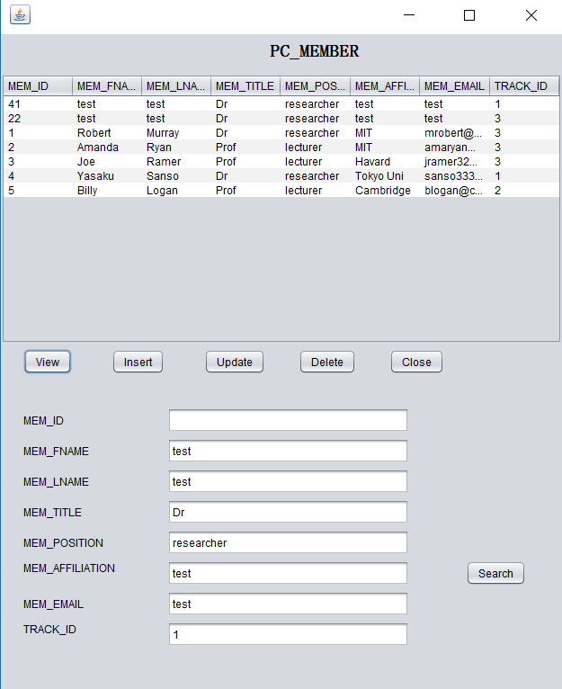

private void jButton3ActionPerformed(java.awt.event.ActionEvent evt) {

String fname = jTextField2.getText();

String lname = jTextField3.getText();

String title= jTextField4.getText();

String position = jTextField5.getText();

String affiliation = jTextField6.getText();

String email = jTextField7.getText();

String trackid = jTextField8.getText();

dtm.setRowCount(0);

try {

stmt = ConferenceApp.conn2.createStatement();

rset = stmt.executeQuery(

"insert into pc_member values(mem_id.nextval,'"+fname+"','"+lname+"','"+title+"','"+position+"','"+affiliation+"','"+email+"','"+trackid+"')");

System.out.println("insert successfully!");

} catch (SQLException f) {

System.out.println(f.getMessage());

} // TODO add your handling code here:

}

**Update**

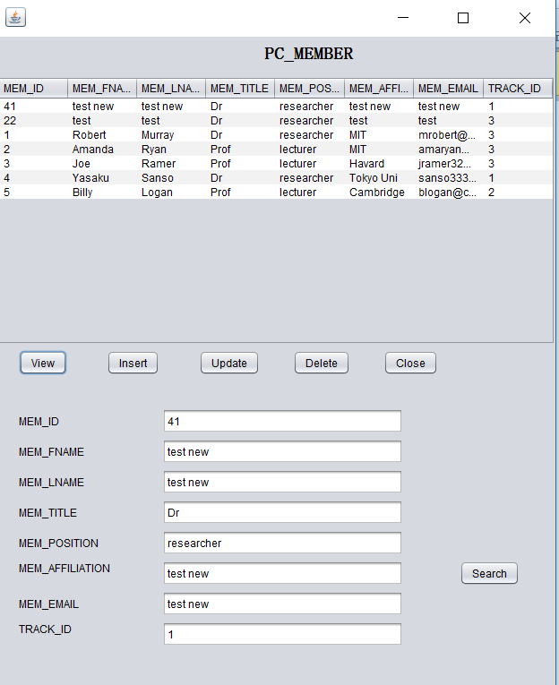

private void jButton4ActionPerformed(java.awt.event.ActionEvent evt) {

int memid = Integer.parseInt(jTextField1.getText());

String fname = jTextField2.getText();

String lname = jTextField3.getText();

String title= jTextField4.getText();

String position = jTextField5.getText();

String affiliation = jTextField6.getText();

String email = jTextField7.getText();

String trackid = jTextField8.getText();

dtm.setRowCount(0);

try {

stmt = ConferenceApp.conn2.createStatement();

rset = stmt.executeQuery(

"update pc_member set mem_fname='"+fname+"',mem_lname='"+lname+"',mem_title='"+title+"',mem_position='"+position+"',"

+ "mem_affiliation='"+affiliation+"',mem_email='"+email+"',track_track_id='"+trackid+"' where mem_id="+memid);

System.out.println("update successfully!");

} catch (SQLException f) {

System.out.println(f.getMessage());

} // TODO add your handling code here:

}

**Delete**

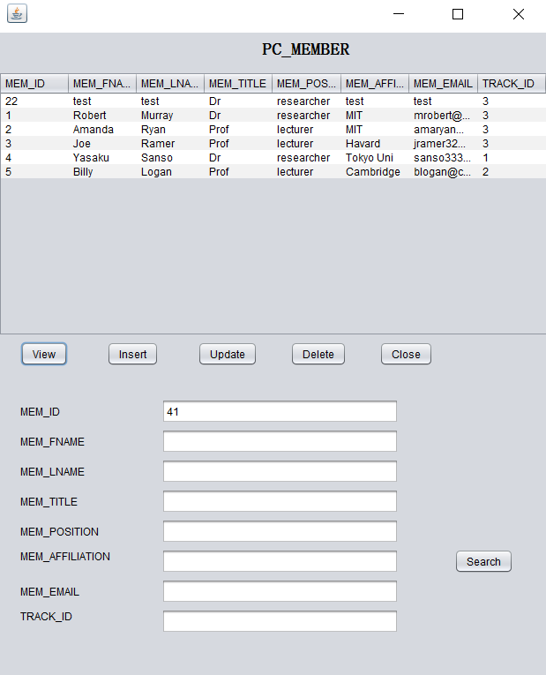

private void jButton5ActionPerformed(java.awt.event.ActionEvent evt) {

int memid = Integer.parseInt(jTextField1.getText());

dtm.setRowCount(0);

try {

stmt = ConferenceApp.conn2.createStatement();

rset = stmt.executeQuery(

"delete from pc_member where mem_id ="+ memid);

System.out.println("Delete successfully!");

}

catch (SQLException f) {

System.out.println(f.getMessage());

} // TODO add your handling code here:

}

**Search by affiliation**

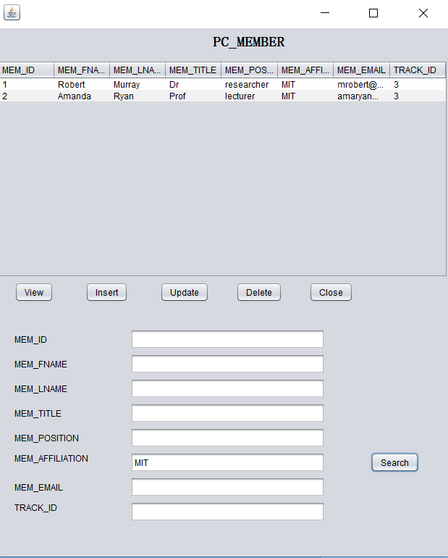

private void jButton6ActionPerformed(java.awt.event.ActionEvent evt) {

String search = jTextField6.getText();

try {

stmt = ConferenceApp.conn2.createStatement();

rset = stmt.executeQuery

("select * from pc_member where mem_affiliation = '" + search+"'");

System.out.println("search successful");

ResultSetMetaData mdata = rset.getMetaData();

dtm.setRowCount(0);

int numberOfColumns = mdata.getColumnCount();

while (rset.next()) {

Object[] rowData = new Object[numberOfColumns];

for (int i = 0; i < rowData.length; i++) {

rowData[i] = rset.getObject(i + 1);

}

dtm.addRow(rowData);

}

} catch (SQLException f) {

System.out.println(f.getMessage());

} // TODO add your handling code here:

}

**Review Frame**

**View**

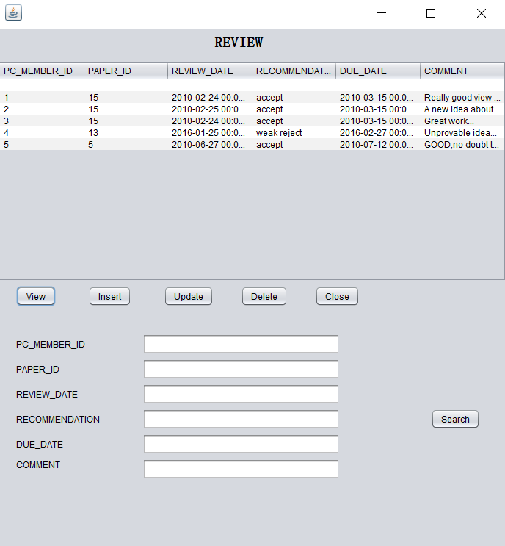

private void jButton1ActionPerformed(java.awt.event.ActionEvent evt) {

try {

dtm.setRowCount(0);

stmt = ConferenceApp.conn2.createStatement();

rset = stmt.executeQuery("select * from review");

ResultSetMetaData mdata = rset.getMetaData();

int numberOfColumns = mdata.getColumnCount();

while (rset.next()) {

Object[] rowData = new Object[numberOfColumns];

for (int i = 0; i < rowData.length; i++) {

rowData[i] = rset.getObject(i + 1);

}

dtm.addRow(rowData);

}

} catch (SQLException f) {

System.out.println(f.getMessage());

} // TODO add your handling code here:

}

**Insert**

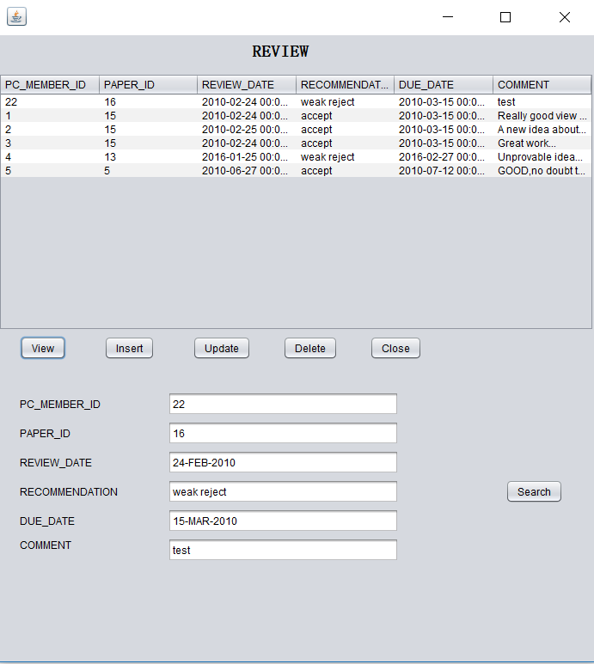

private void jButton3ActionPerformed(java.awt.event.ActionEvent evt) {

int pcid = Integer.parseInt(jTextField1.getText());

int paperid = Integer.parseInt(jTextField2.getText());

String reviewdate = jTextField3.getText();

String recommend= jTextField4.getText();

String duedate = jTextField5.getText();

String comment = jTextField6.getText();

dtm.setRowCount(0);

try {

stmt = ConferenceApp.conn2.createStatement();

rset = stmt.executeQuery(

"insert into review values('"+pcid+"','"+paperid+"','"+reviewdate+"','"+recommend+"','"+duedate+"','"+comment+"')");

System.out.println("insert successfully!");

} catch (SQLException f) {

System.out.println(f.getMessage());

} // TODO add your handling code here:

}

**Update**

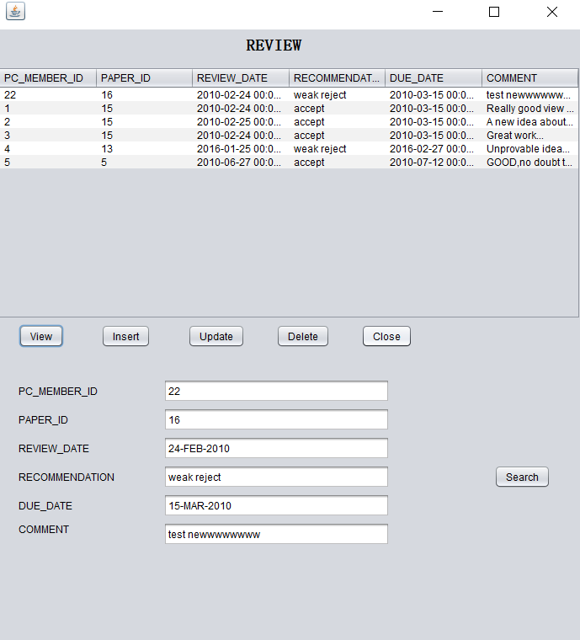

private void jButton4ActionPerformed(java.awt.event.ActionEvent evt) {

int pcid = Integer.parseInt(jTextField1.getText());

int paperid = Integer.parseInt(jTextField2.getText());

String reviewdate = jTextField3.getText();

String recommend= jTextField4.getText();

String duedate = jTextField5.getText();

String comment = jTextField6.getText();

dtm.setRowCount(0);

try {

stmt = ConferenceApp.conn2.createStatement();

rset = stmt.executeQuery(

"update review set review_date='"+reviewdate+"',recommendation='"+recommend+"',due_date='"+duedate+"',review_comment='"+comment+"' where pc_member_mem_id ="+ pcid +" and paper_paper_id="+paperid);

System.out.println("update successfully!");

} catch (SQLException f) {

System.out.println(f.getMessage());

} // TODO add your handling code here:

}

**Delete**

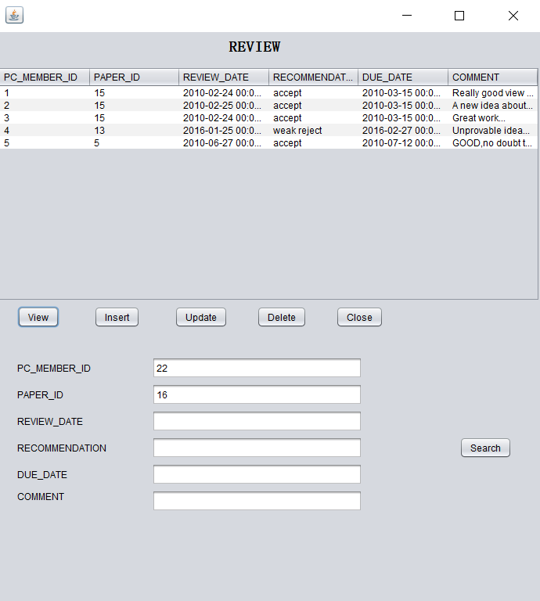

private void jButton5ActionPerformed(java.awt.event.ActionEvent evt) {

int pcid = Integer.parseInt(jTextField1.getText());

int paperid = Integer.parseInt(jTextField2.getText());

dtm.setRowCount(0);

try {

stmt = ConferenceApp.conn2.createStatement();

rset = stmt.executeQuery(

"delete from review where pc_member_mem_id ="+ pcid +" and paper_paper_id="+paperid);

System.out.println("Delete successfully!");

}

catch (SQLException f) {

System.out.println(f.getMessage());

} // TODO add your handling code here:

}

**Search by recommendation**

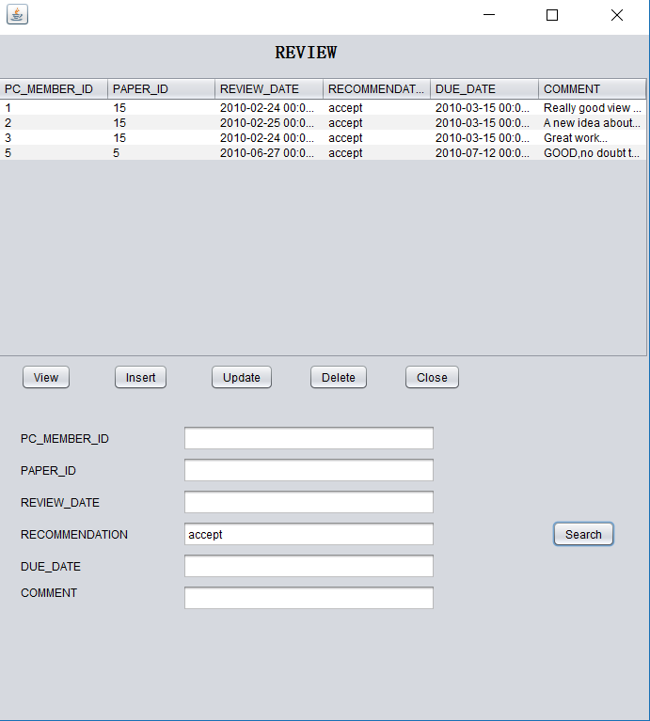

private void jButton6ActionPerformed(java.awt.event.ActionEvent evt) {

String search = jTextField4.getText();

try {

stmt = ConferenceApp.conn2.createStatement();

rset = stmt.executeQuery

("select * from review where recommendation = '" + search+"'");

System.out.println("search successful");

ResultSetMetaData mdata = rset.getMetaData();

dtm.setRowCount(0);

int numberOfColumns = mdata.getColumnCount();

while (rset.next()) {

Object[] rowData = new Object[numberOfColumns];

for (int i = 0; i < rowData.length; i++) {

rowData[i] = rset.getObject(i + 1);

}

dtm.addRow(rowData);

}

} catch (SQLException f) {

System.out.println(f.getMessage());

} // TODO add your handling code here:

}

**Submission Frame**

**View**

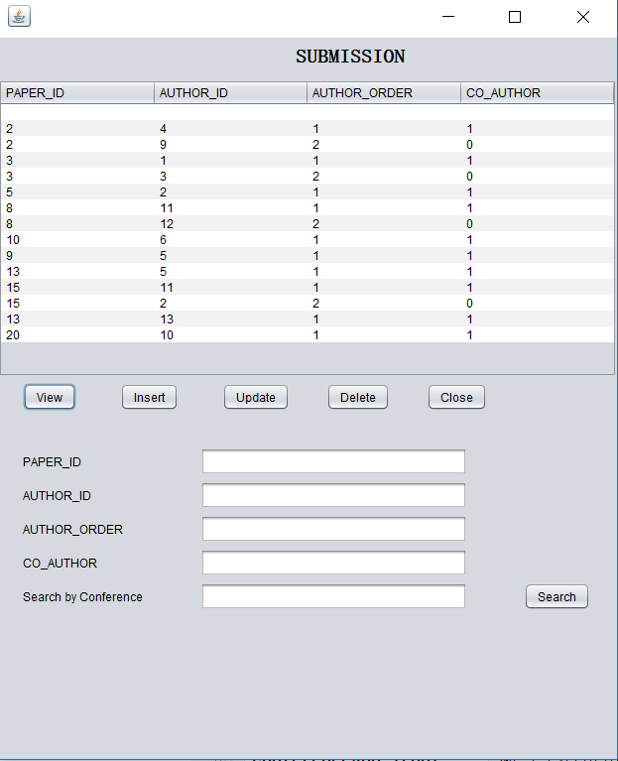

private void jButton1ActionPerformed(java.awt.event.ActionEvent evt) {

try {

dtm.setRowCount(0);

stmt = ConferenceApp.conn2.createStatement();

rset = stmt.executeQuery("select * from submission");

ResultSetMetaData mdata = rset.getMetaData();

int numberOfColumns = mdata.getColumnCount();

while (rset.next()) {

Object[] rowData = new Object[numberOfColumns];

for (int i = 0; i < rowData.length; i++) {

rowData[i] = rset.getObject(i + 1);

}

dtm.addRow(rowData);

}

} catch (SQLException f) {

System.out.println(f.getMessage());

} // TODO add your handling code here:

}

**Insert**

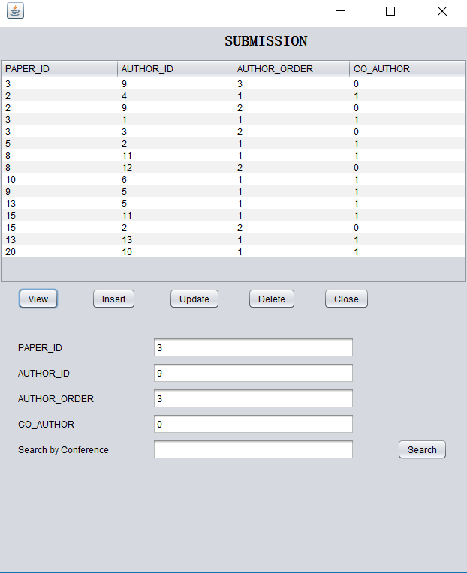

private void jButton3ActionPerformed(java.awt.event.ActionEvent evt) {

int paperid = Integer.parseInt(jTextField1.getText());

int authorid = Integer.parseInt(jTextField2.getText());

String order = jTextField3.getText();

String co_author= jTextField4.getText();

dtm.setRowCount(0);

try {

stmt = ConferenceApp.conn2.createStatement();

rset = stmt.executeQuery(

"insert into submission values('"+paperid+"','"+authorid+"','"+order+"','"+co_author+"')");

System.out.println("insert successfully!");

} catch (SQLException f) {

System.out.println(f.getMessage());

} // TODO add your handling code here:

}

**Update**

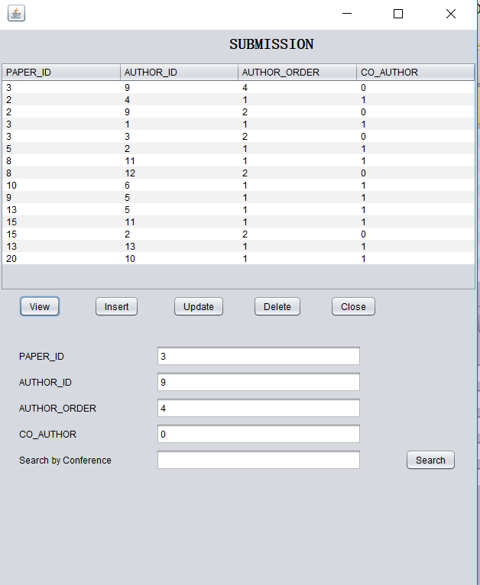

private void jButton4ActionPerformed(java.awt.event.ActionEvent evt) {

int paperid = Integer.parseInt(jTextField1.getText());

int authorid = Integer.parseInt(jTextField2.getText());

String order = jTextField3.getText();

String co_author= jTextField4.getText();

dtm.setRowCount(0);

try {

stmt = ConferenceApp.conn2.createStatement();

rset = stmt.executeQuery(

"update submission set author_order='"+order+"',co_author='"+co_author+"'where paper_paper_id="+paperid+" and author_author_id="+authorid);

System.out.println("update successfully!");

} catch (SQLException f) {

System.out.println(f.getMessage());

} // TODO add your handling code here:

}

**Delete**

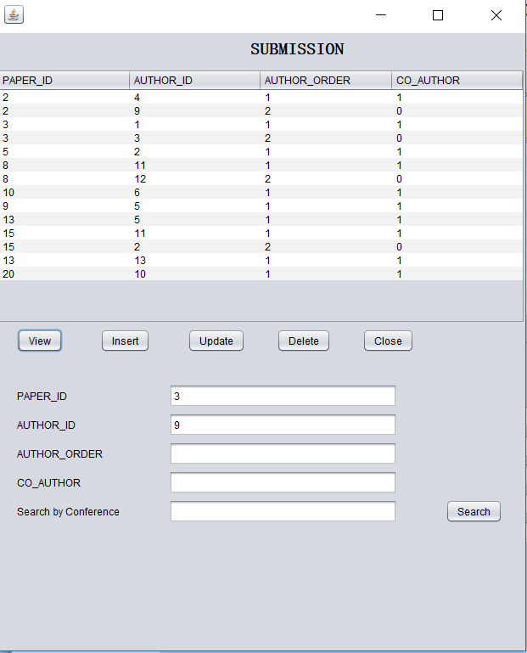

private void jButton5ActionPerformed(java.awt.event.ActionEvent evt) {

int trackid = Integer.parseInt(jTextField1.getText());

dtm.setRowCount(0);

try {

stmt = ConferenceApp.conn2.createStatement();

rset = stmt.executeQuery(

"delete from track where track_id ="+ trackid);

System.out.println("Delete successfully!");

}

catch (SQLException f) {

System.out.println(f.getMessage());

} // TODO add your handling code here:

}

**Search by conference name**

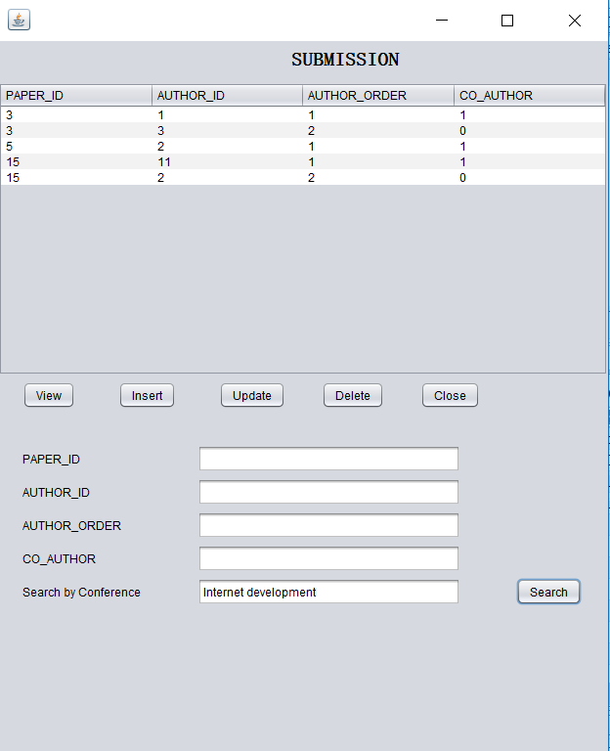

private void jButton6ActionPerformed(java.awt.event.ActionEvent evt) {

String search = jTextField7.getText();

try {

stmt = ConferenceApp.conn2.createStatement();

rset = stmt.executeQuery

("select * from track t join conference@FIT5148A c on t.conference_con_id=c.con_id where c.con_name = '" + search+"'");

System.out.println("search successful");

ResultSetMetaData mdata = rset.getMetaData();

dtm.setRowCount(0);

int numberOfColumns = mdata.getColumnCount();

while (rset.next()) {

Object[] rowData = new Object[numberOfColumns];

for (int i = 0; i < rowData.length; i++) {

rowData[i] = rset.getObject(i + 1);

}

dtm.addRow(rowData);

}

} catch (SQLException f) {

System.out.println(f.getMessage());

} // TODO add your handling code here:

}

**Paper Frame**

**View**

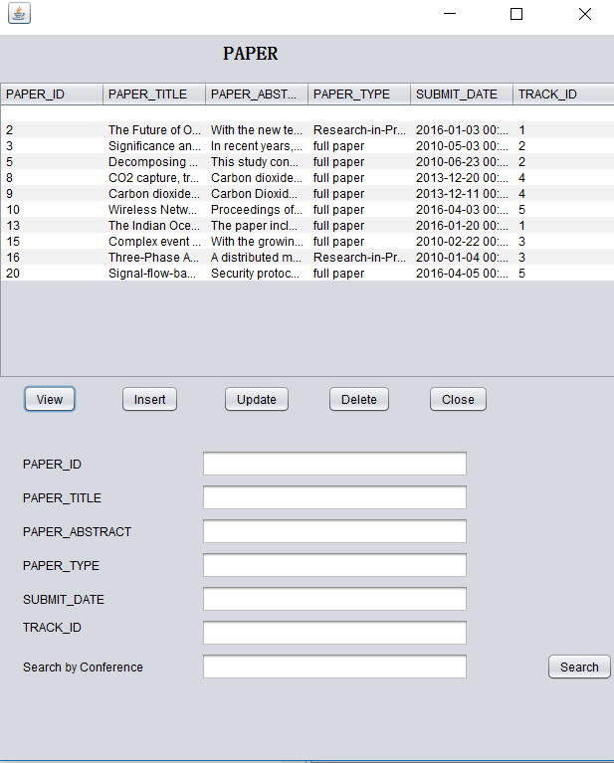

private void jButton1ActionPerformed(java.awt.event.ActionEvent evt) {

try {

dtm.setRowCount(0);

stmt = ConferenceApp.conn2.createStatement();

rset = stmt.executeQuery("select * from paper");

ResultSetMetaData mdata = rset.getMetaData();

int numberOfColumns = mdata.getColumnCount();

while (rset.next()) {

Object[] rowData = new Object[numberOfColumns];

for (int i = 0; i < rowData.length; i++) {

rowData[i] = rset.getObject(i + 1);

}

dtm.addRow(rowData);

}

} catch (SQLException f) {

System.out.println(f.getMessage());

} // TODO add your handling code here:

}

**Insert**

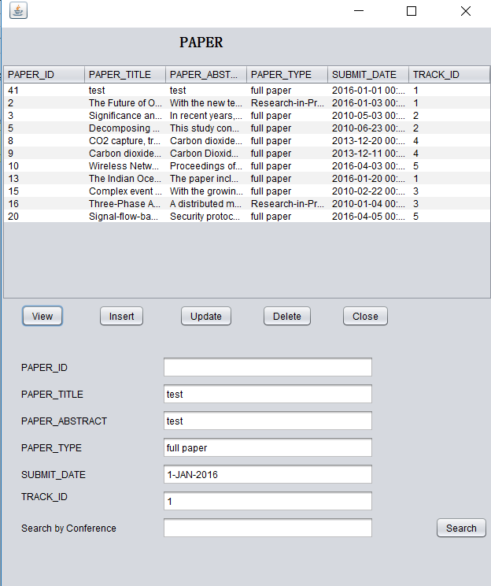

private void jButton3ActionPerformed(java.awt.event.ActionEvent evt) {

//int paperid = Integer.parseInt(jTextField1.getText());

String title = jTextField2.getText();

String paperabstract = jTextField3.getText();

String type= jTextField4.getText();

String subdate = jTextField5.getText();

String trackid = jTextField6.getText();

dtm.setRowCount(0);

try {

stmt = ConferenceApp.conn2.createStatement();

rset = stmt.executeQuery(

"insert into paper values(paper_id.nextval,'"+title+"','"+paperabstract+"','"+type+"','"+subdate+"','"+trackid+"')");

System.out.println("insert successfully!");

} catch (SQLException f) {

System.out.println(f.getMessage());

} // TODO add your handling code here:

}

**Update**

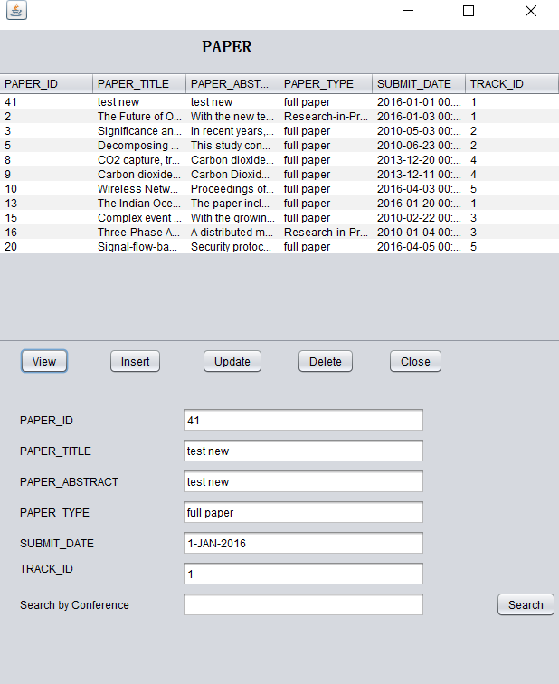

private void jButton4ActionPerformed(java.awt.event.ActionEvent evt) {

int paperid = Integer.parseInt(jTextField1.getText());

String title = jTextField2.getText();

String paperabstract = jTextField3.getText();

String type= jTextField4.getText();

String subdate = jTextField5.getText();

String trackid = jTextField6.getText();

dtm.setRowCount(0);

try {

stmt = ConferenceApp.conn2.createStatement();

rset = stmt.executeQuery(

"update paper set paper_title='"+title+"',paper_abstract='"+paperabstract+"',paper_type='"+type+"',submit_date='"+subdate+"',"

+ "track_track_id='"+trackid+"' where paper_id="+paperid);

System.out.println("update successfully!");

} catch (SQLException f) {

System.out.println(f.getMessage());

} // TODO add your handling code here:

}

**Delete**

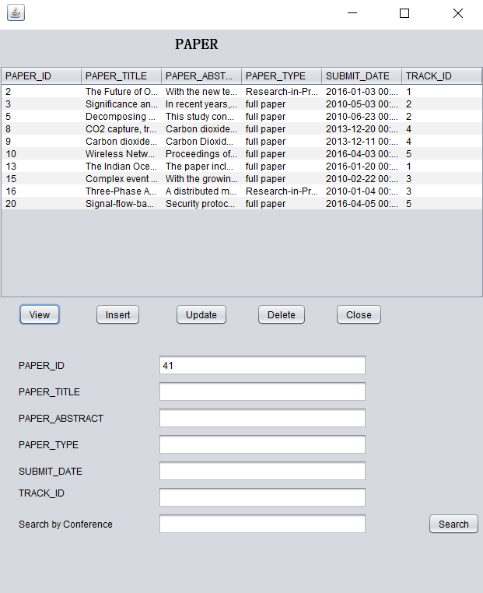

private void jButton5ActionPerformed(java.awt.event.ActionEvent evt) {

int paperid = Integer.parseInt(jTextField1.getText());

dtm.setRowCount(0);

try {

stmt = ConferenceApp.conn2.createStatement();

rset = stmt.executeQuery(

"delete from paper where paper_id ="+ paperid);

System.out.println("Delete successfully!");

}

catch (SQLException f) {

System.out.println(f.getMessage());

} // TODO add your handling code here:

}

**Search by conference name**

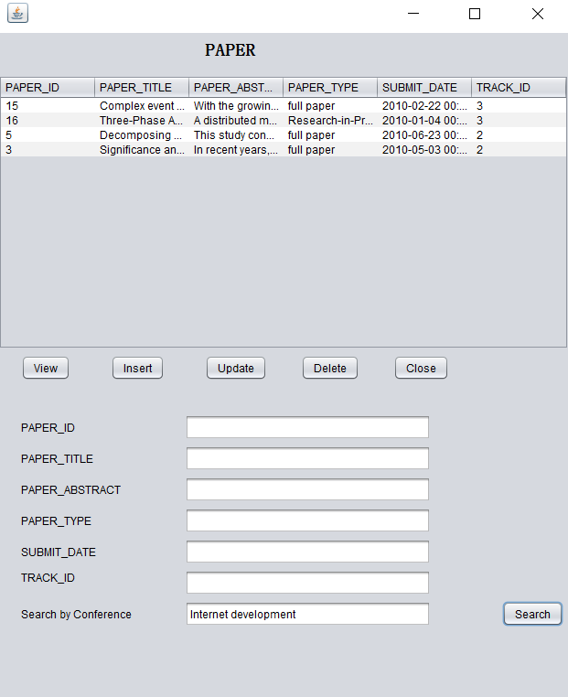

private void jButton6ActionPerformed(java.awt.event.ActionEvent evt) {

String search = jTextField7.getText();

try {

stmt = ConferenceApp.conn2.createStatement();

rset = stmt.executeQuery

("select * from paper p join track@FIT5148B t on t.track_id = p.track_track_id join conference@FIT5148A c on t.conference_con_id=c.con_id where c.con_name = '" + search+"'");

System.out.println("search successful");

ResultSetMetaData mdata = rset.getMetaData();

dtm.setRowCount(0);

int numberOfColumns = mdata.getColumnCount();

while (rset.next()) {

Object[] rowData = new Object[numberOfColumns];

for (int i = 0; i < rowData.length; i++) {

rowData[i] = rset.getObject(i + 1);

}

dtm.addRow(rowData);

}

} catch (SQLException f) {

System.out.println(f.getMessage());

} // TODO add your handling code here:

}

**Award Frame**

**View**

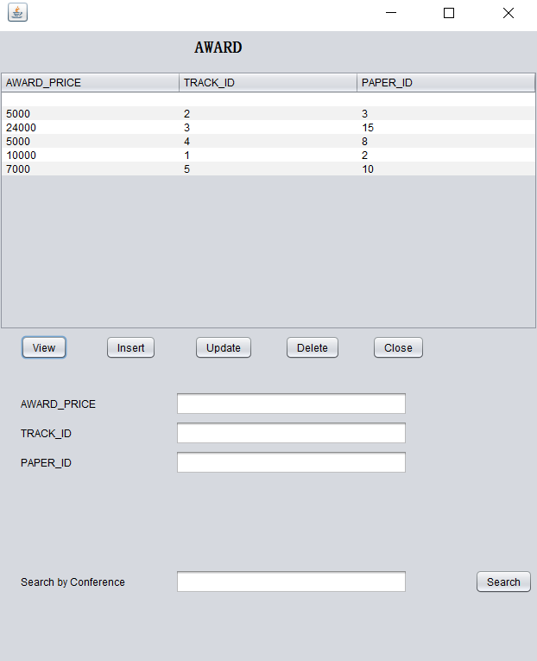

private void jButton1ActionPerformed(java.awt.event.ActionEvent evt) {

try {

dtm.setRowCount(0);

stmt = ConferenceApp.conn2.createStatement();

rset = stmt.executeQuery("select * from award");

ResultSetMetaData mdata = rset.getMetaData();

int numberOfColumns = mdata.getColumnCount();

while (rset.next()) {

Object[] rowData = new Object[numberOfColumns];

for (int i = 0; i < rowData.length; i++) {

rowData[i] = rset.getObject(i + 1);

}

dtm.addRow(rowData);

}

} catch (SQLException f) {

System.out.println(f.getMessage());

} // TODO add your handling code here:

}

**Delete**

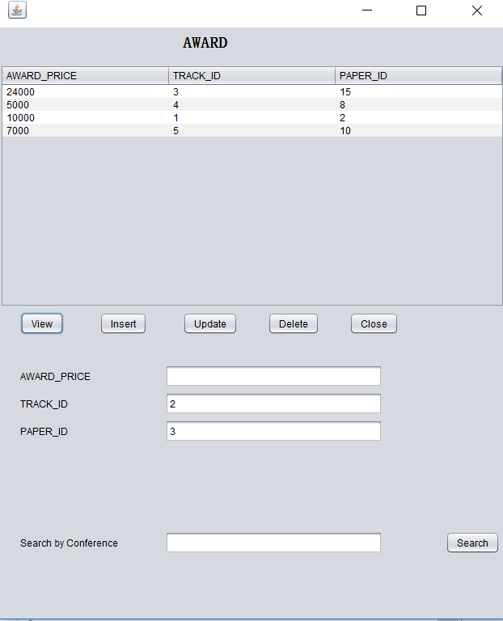

private void jButton5ActionPerformed(java.awt.event.ActionEvent evt) {

int trackid = Integer.parseInt(jTextField2.getText());

int paperid = Integer.parseInt(jTextField3.getText());

dtm.setRowCount(0);

try {

stmt = ConferenceApp.conn2.createStatement();

rset = stmt.executeQuery(

"delete from award where track_track_id='"+trackid+"' and paper_paper_id='"+paperid+"'");

System.out.println("Delete successfully!");

}

catch (SQLException f) {

System.out.println(f.getMessage());

} // TODO add your handling code here:

}

**Insert**

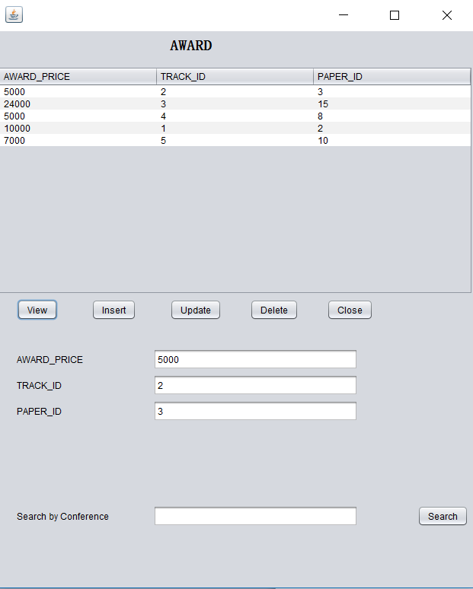

private void jButton3ActionPerformed(java.awt.event.ActionEvent evt) {

int price = Integer.parseInt(jTextField1.getText());

int trackid = Integer.parseInt(jTextField2.getText());

int paperid = Integer.parseInt(jTextField3.getText());

dtm.setRowCount(0);

try {

stmt = ConferenceApp.conn2.createStatement();

rset = stmt.executeQuery(

"insert into award values('"+price+"','"+trackid+"','"+paperid+"')");

System.out.println("insert successfully!");

} catch (SQLException f) {

System.out.println(f.getMessage());

} // TODO add your handling code here:

}

**Update**

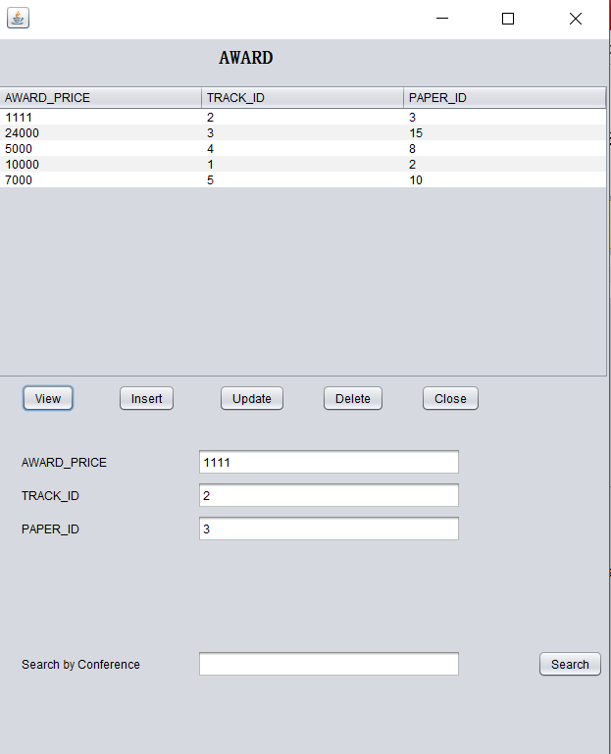

private void jButton4ActionPerformed(java.awt.event.ActionEvent evt) {

int price = Integer.parseInt(jTextField1.getText());

int trackid = Integer.parseInt(jTextField2.getText());

int paperid = Integer.parseInt(jTextField3.getText());

dtm.setRowCount(0);

try {

stmt = ConferenceApp.conn2.createStatement();

rset = stmt.executeQuery(

"update award set award_price='"+price+"' where track_track_id='"+trackid+"' and paper_paper_id='"+paperid+"'");

System.out.println("update successfully!");

} catch (SQLException f) {

System.out.println(f.getMessage());

} // TODO add your handling code here:

}

**Search by conference name**

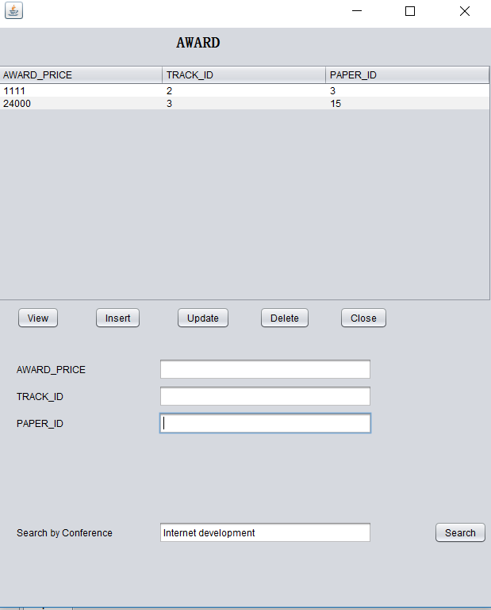

private void jButton6ActionPerformed(java.awt.event.ActionEvent evt) {

String search = jTextField7.getText();

try {

stmt = ConferenceApp.conn2.createStatement();

rset = stmt.executeQuery

("select * from award a join track@FIT5148B t on t.track_id = a.track_track_id join conference@FIT5148A c on t.conference_con_id=c.con_id where c.con_name = '" + search+"'");

System.out.println("search successful");

ResultSetMetaData mdata = rset.getMetaData();

dtm.setRowCount(0);

int numberOfColumns = mdata.getColumnCount();

while (rset.next()) {

Object[] rowData = new Object[numberOfColumns];

for (int i = 0; i < rowData.length; i++) {

rowData[i] = rset.getObject(i + 1);

}

dtm.addRow(rowData);

}

} catch (SQLException f) {

System.out.println(f.getMessage());

} // TODO add your handling code here:

}

**Task6**

I’m also doing FIT5046Mobile and distributed computing system this semester. So I try to use RESTful service to connect from HTML web page to the databse FIT5148B

1. I create entity based on the database and RESTful service based on the entity

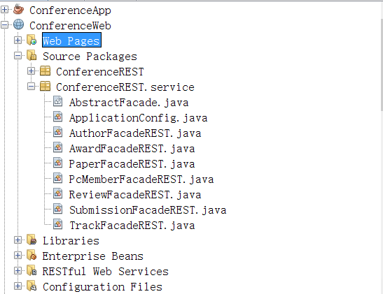

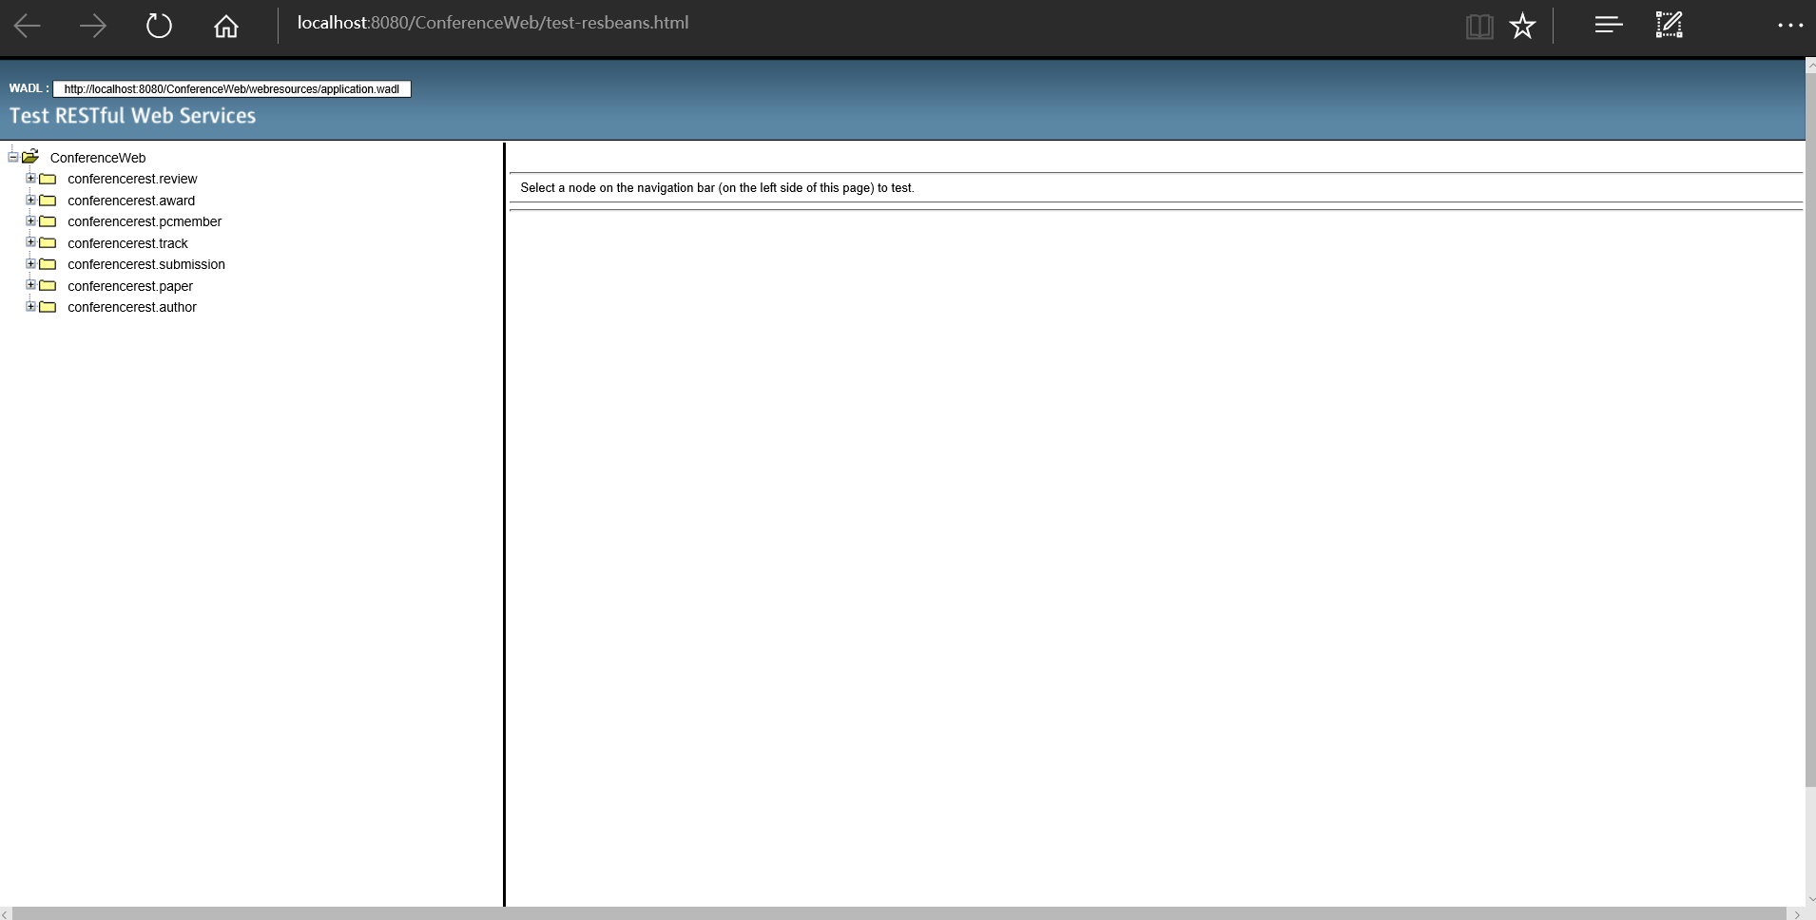

2. I create Javascript and index page

JavaScript:

var request = null;

var rooturl = "http://localhost:8080/ConferenceWeb/webresources/ConferenceREST.author";

function createRequest() {

try {

request = new XMLHttpRequest();

} catch (trymicrosoft) {

try {

request = new ActiveXObject("MsXML2.XMLHTTP");

} catch (othermicrosoft) {

try {

request = new ActiveXObject("Microsoft.XMLHTTP");

} catch (failed) {

request = null;

}

}

}

if (request == null)

alert("Error creating request object!");

}

function getAllAuthor()

{

document.getElementById('authroId').value = "";

document.getElementById('authorFname').value = "";

document.getElementById('authorLname').value = "";

document.getElementById('authorAffiliation').value = "";

document.getElementById('authorCountry').value = "";

document.getElementById('authorEmail').value = "";

document.getElementById('authorNumber').value = "";

createRequest();

request.onreadystatechange = handleListJSONResponse;

request.open("GET", rooturl, true);

request.send(null);

}

function getAuthor()

{

document.getElementById("output").innerHTML = "";

document.getElementById('authorFname').value = "";

document.getElementById('authorLname').value = "";

document.getElementById('authorAffiliation').value = "";

document.getElementById('authorCountry').value = "";

document.getElementById('authorEmail').value = "";

document.getElementById('authorNumber').value = "";

createRequest();

var id = document.getElementById("authorId").value;

var url = rooturl + "/" + id;

request.onreadystatechange = handleJSONResponse;

request.open("GET", url, true);

request.send(null);

}

function addAuthor()

{

document.getElementById("output").innerHTML = "";

var authorId = document.getElementById('authorId').value;

var authorFname = document.getElementById('authorFname').value;

var authorLname = document.getElementById('authorLname').value;

var authorAffiliation = document.getElementById('authorAffiliation').value;

var authorCountry = document.getElementById('authorCountry').value;

var authorEmail = document.getElementById('authorEmail').value;

var authorNumber = document.getElementById('authorNumber').value;

createRequest();

var data = JSON.stringify({"authorId": authorId.toString(),

"authorFname": authorFname.toString(),

"authorLname": authorLname.toString(),

"authorAffiliation": authorAffiliation.toString(),

"authorCountry": authorCountry.toString(),

"authorEmail": authorEmail.toString(),

"authorNumber": authorNumber.toString(),

});

request.open("POST", rooturl);

request.setRequestHeader('Content-type', 'application/json');

request.setRequestHeader("Content-Length", data.length);

request.setRequestHeader('Accept', 'application/json');

request.send(data);

document.getElementById('authorId').value = "";

document.getElementById('authorFname').value = "";

document.getElementById('authorLname').value = "";

document.getElementById('authorAffiliation').value = "";

document.getElementById('authorCountry').value = "";

document.getElementById('authorEmail').value = "";

document.getElementById('authorNumber').value = "";

}

function deleteAuthor()

{

document.getElementById("output").innerHTML = "";

createRequest();

var id = document.getElementById("authorId").value;

var url = rooturl + "/" + id;

request.open("DELETE", url, true);

request.send(null);

document.getElementById('authorId').value = "";

document.getElementById('authorFname').value = "";

document.getElementById('authorLname').value = "";

document.getElementById('authorAffiliation').value = "";

document.getElementById('authorCountry').value = "";

document.getElementById('authorEmail').value = "";

document.getElementById('authorNumber').value = "";

}

function updateAuthor()

{

document.getElementById("output").innerHTML = "";

var authorId = document.getElementById('authorId').value;

var authorFname = document.getElementById('authorFname').value;

var authorLname = document.getElementById('authorLname').value;

var authorAffiliation = document.getElementById('authorAffiliation').value;

var authorCountry = document.getElementById('authorCountry').value;

var authorEmail = document.getElementById('authorEmail').value;

var authorNumber = document.getElementById('authorNumber').value;

createRequest();

var data = JSON.stringify({"authorId": authorId.toString(),

"authorFname": authorFname.toString(),

"authorLname": authorLname.toString(),

"authorAffiliation": authorAffiliation.toString(),

"authorCountry": authorCountry.toString(),

"authorEmail": authorEmail.toString(),

"authorNumber": authorNumber.toString()});

var url = rooturl + "/" + docId;

request.open("PUT", url);

request.setRequestHeader('Content-type', 'application/json');

request.setRequestHeader("Content-Length", data.length);

request.setRequestHeader('Accept', 'application/json');

request.send(data);

document.getElementById('authorId').value = "";

document.getElementById('authorFname').value = "";

document.getElementById('authorLname').value = "";

document.getElementById('authorAffiliation').value = "";

document.getElementById('authorCountry').value = "";

document.getElementById('authorEmail').value = "";

document.getElementById('authorNumber').value = "";

}

function handleJSONResponse() {

if (request.readyState == 4 && request.status == 200)

{

var det = JSON.parse(request.responseText);

document.getElementById('authorId').value = det.authorId;

document.getElementById('authorFname').value = det.authorFname;

document.getElementById('authorLname').value = det.authorLname;

document.getElementById('authorAffiliation').value = det.authorAffiliation;

document.getElementById('authorCountry').value = det.authorCountry;

document.getElementById('authorEmail').value = det.authorEmail;

document.getElementById('authorNumber').value = det.authorNumber;

}

}

function handleListJSONResponse() {

if (request.readyState == 4 && request.status == 200)

{

var det = JSON.parse(request.responseText);

var output = "<table border = '1'>";

output += "<tr>" + "<th>authorId</th>" + "<th>authorFname</th>" + "<th>authorLname</th>"

+ "<th>authorAffiliation</th>" + "<th>authorCountry</th>" + "<th>authorEmail</th>" + "<th>authorNumber</th>"

+ "</tr>";

for (var i = 0; i < det.length; i++) {

output += "<tr>";

output += "<td>" + det[i].authorId + "</td>";

output += "<td>" + det[i].authorFname + "</td>";

output += "<td>" + det[i].authorLname + "</td>";

output += "<td>" + det[i].authorAffiliation + "</td>";

output += "<td>" + det[i].authorCountry + "</td>";

output += "<td>" + det[i].authorEmail + "</td>";

output += "<td>" + det[i].authorNumber + "</td>";

output += "</tr>";

}

output += "</table>";

document.getElementById("output").innerHTML = output;

}

}

**Index web page**

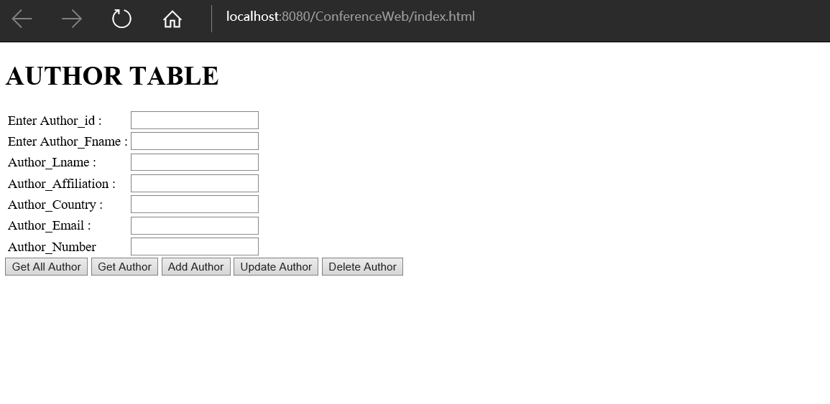

<!DOCTYPE html>

<html>

<head>

<title>Doctor Service</title>

<meta charset="UTF-8">

<meta name="viewport" content="width=device-width, initial-scale=1.0">

<script src="js/ConferenceService.js"></script>

</head>

<body>

<h1> AUTHOR TABLE</h1>

<table>

<tr>

<td>Enter Author_id : </td>

<td><input type="text" id="authroId" size="20"/></td>

</tr>

<tr>

<td>Enter Author_Fname : </td>

<td><input type="text" id="authorFname" size="20"/></td>

</tr>

<tr>

<td>Author_Lname : </td>

<td> <input type="text" id="authorLname" size="20"/> </td>

</tr>

<tr>

<td>Author_Affiliation : </td>

<td> <input type="text" id="authorAffiliation" size="20"/></td>

</tr>

<tr>

<td>Author_Country : </td>

<td> <input type="text" id="authorCountry" size="20"/></td>

</tr>

<tr>

<td>Author_Email : </td>

<td> <input type="text" id="authorEmail" size="20"/></td>

</tr>

<tr>

<td>Author_Number </td>

<td> <input type="text" id="authorNumber" size="20"/></td>

</tr>

</table>

<input type="button" value="Get All Author" onclick="getAllAuthor()"/>

<input type="button" value="Get Author" onclick="getAuthor()"/>

<input type="button" value="Add Author" onclick="addAuthor()"/>

<input type="button" value="Update Author" onclick="updateAuthor()"/>

<input type="button" value="Delete Author" onclick="deleteAuthor()"/>

<p id="output"></p>

</body>

</html>